Bibliographic study

Geology of Scotland and Background knowledge on Scottish coal mines

# Geological context

## Bedrock Geology

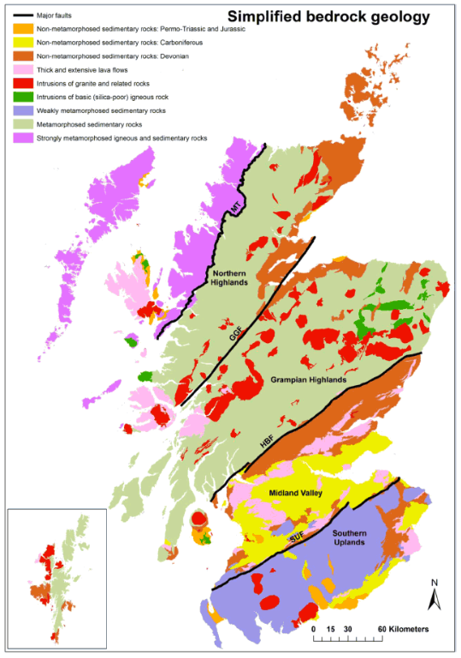

*Figure1. Simplified Bedrock Geology of Scotland (Gillespie et al., 2013)*

The Midland Valley of Scotland (MVS) is a 80 km wide, > 150 km long WNW-ESE trending Late Paleozoic sedimentary basin (Underhill et al., 2007) that developed on the eroded and deformed remnant of the Caledonian Mountains, formed during the Caledonian Orogeny with the closure of the Iapetus Ocean (Cameron and Stephenson, 1985; Underhill, 1998; Read et al., 2002). It is separated from the Grampian Highlands by the Highland Boundary Fault, and from the Southern Uplands by the Southern Upland Fault. Both of those SW-NE striking fault formed major lineaments during the Caledonian Orogeny (Cameron and Stephenson, 1985).

The crystalline basement, found beneath much of Scotland, is formed by weakly to strongly metamorphosed Lower Paleozoic sedimentary rocks. Highly metamorphosed rocks (i.e. gneiss) seen in the Northwest Highlands are likely to be similar to rocks found in the deepest part of Scotland. They originally corresponded to intrusions of granitic and basaltic rocks. In the Northern Highlands and Grampian Highlands, the basement is mainly characterized by a thick sequence of metamorphosed sediments (originally interbedded sandstone and mudstone units). Weakly metamorphosed sediments (sandstone and shale) disrupted by folding, faulting and tilting can be found in the Southern Uplands. Those are intersected by intrusions of basic ingenious rock, generally in the form of laccoliths, as well as granite and other related rocks intrusions. The Midland Valley has only a few small granite intrusions at outcrop but contains numerous minor intrusions, mainly of basaltic and andesitic composition. The metamorphic basement only outcrop along the main faults together with the Devonian Old Red Sandstone sedimentary rocks.

According to geophysical data, the basement-cover boundary is situated at about 8 km depth in the central part of the Midland Valley, against about 15 km depth below the Highlands and Southern Uplands blocks. The basement beneath the MVS and highlands is about 20-25 km thick, with the base of the crust being situated at ~33 km depth, and shows different seismic characteristic to the basement beneath the Southern Uplands. However, some SE extension of the Midland Valley basement rocks have been suggested as a result of similar xenolith assemblages found in intrusions on both sides of the Southern Upland Fault.

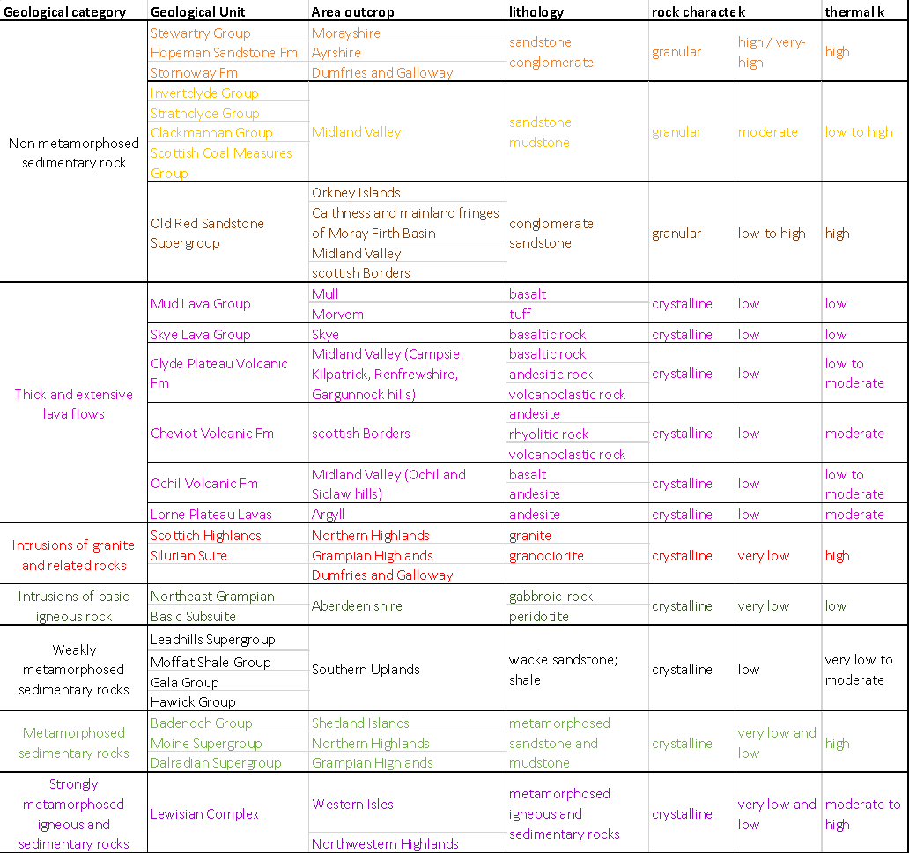

*Table 1. Main rock types in Scotland (Gillespie et al., 2013)*

## Basin stratigraphy

The MVS mainly consists of a thick sequence of non-metamorphized sedimentary rocks deposited in basin environments during the Devonian-Carboniferous period. Those accumulated as 10 m thick cycles (with maximum of ~30 m), resulting in repeated layers of sandstones, siltstones and mudstones with beds of limestone, coal, fireclay, ironstone and oil-shale (Cameron and Stephenson, 1985). They are intersected by lava flows (mainly of basaltic and andesitic composition) and by pyroclastic rocks up to several kilometers in thickness.

Carboniferous sedimentary succession in the MVS (Browne et al., 1999) is subdivided into four main groups: the Inverclyde, Strathclyde, Clackmannan and Coal Measures groups (Browne et al., 1999).

The Strathclyde Group is separated into ten lithostratigraphic formations that reflect intensive changes in facies during the early-middle Mississippian times. In Fife and East Lothian, the sedimentary rocks form a significant south-westerly prograding, easterly thickening, sandy clastic, fluvial-deltaic wedge (Greensmith, 1962, 1965; Browne and Monro, 1989). Coeval sedimentation in West Lothian and Edinburgh areas is however dominated by lacustrine oil-shales (i.e. “Lake Cadell’’, Cadell, 1925; Greensmith, 1962, 1965).

The Middle Mississippian-Lower Pennsylvanian Clackmannan Group comprises the Lower Limestone (LLGS), Limestone Coal (LSC), Upper Limestone (ULGS) and the Passage (PGP) formations. Whilst the Lower and Upper Limestone formations represent more marine successions, the Limestone Coal Formation represents a return to non-marine/paralic conditions from which significant quantities of coal have been extracted. The Passage Formation marks the upward transition into coal-bearing strata of the Scottish Coal Measures Group.

The Coal Measures Group represents the youngest observable set of sedimentary rocks in the eastern part of the basin. They are subdivided into the Lower (LCMS), Middle (MCMS) and Upper Coal Measures formations (UCMS).

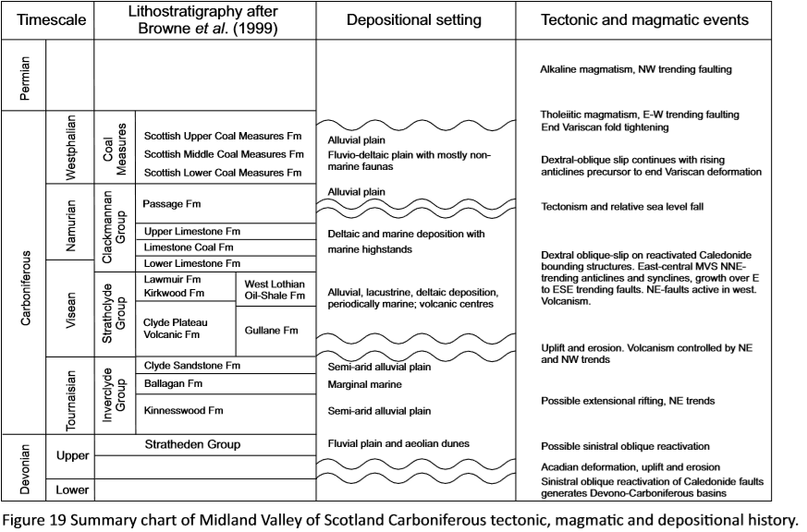

*Figure 2. Summary chart of MVS Carboniferous tectonic, magmatic and depositional history (Monaghan, 2014)*

## Structure and Basin history

Fault in the MVS have dips varying from near-vertical to 50° with evidence of normal (e.g. East Ochil), reversed (e.g. Pentland) and strike-slip (e.g. Crossgatehall, Adross Fault) movements. The E-W trending West and East Ochil faults, the NW-trending Dechmont Fault and the NE-trending Pentland Fault, with throws of up to 1.8 km, represent the main basin bounding structures. Faults with smaller throws of up to ~800 m (e.g. the E-W to NE-SW striking Wilsontown, Campsie faults) bound parts of the basin while faults with throws ranging from ~ 200 to 400 m (e.g. Comedie, Bothwell, Crossgatehall faults) only offset the basin fill succession.

The MVS is moreover composed of a series of inter-related depo-centers and intra-basinal highs that results from a complex basin evolution during the Carboniferous, which has been subjected to many controversies (Underhill et al., 2008). This basin history has been summarized in four main stages:

* Late Devonian to Early Carboniferous basin formation in the Variscan foreland, following the closure of the Iapetus Ocean (Silurien times 440-425 Ma, see Siccar Point Unconformity Silurien/Devonien Old Red Sandstone)
* Mid to Late Carboniferous basin formation to inversion
* Latest Carboniferous to Permian tholeiitic magmatism and post-orogenic extension
* Post Carboniferous deposition (burial and lithification of rocks), uplift/folding and erosion (~300 Myr)

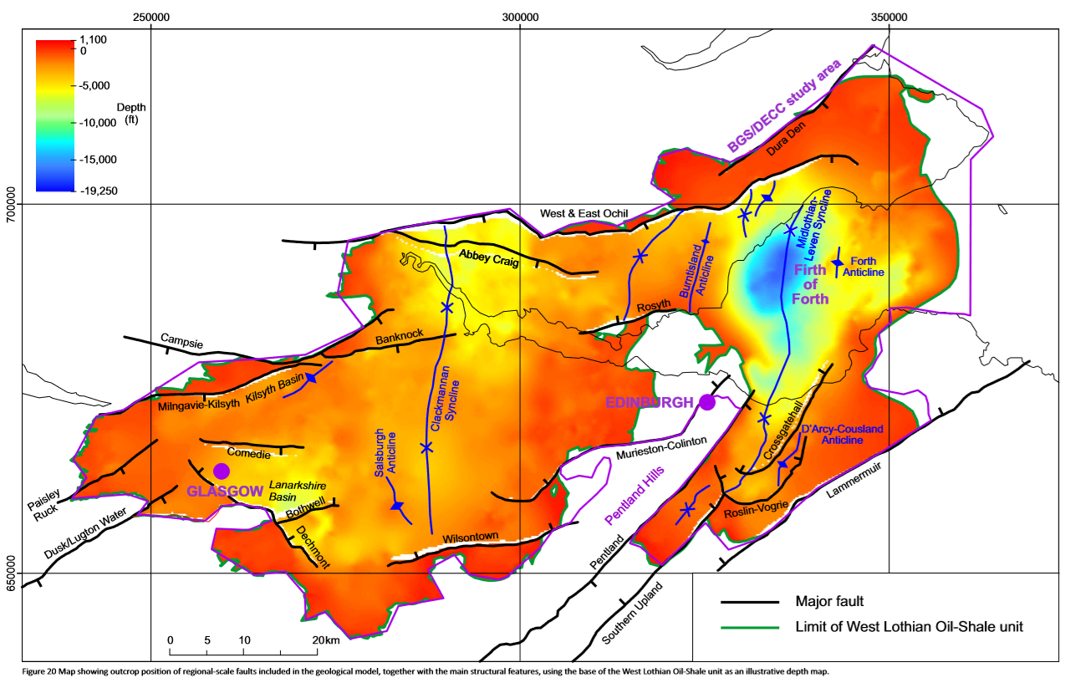

*Figure 3. Map showing outcrop position of regional-scale faults included in the geological model, together with the main structural features, using the base of the West Lothian Oil-Shale unit as an illustrative depth map* (Monaghan, 2014)*.*

Major NNE-SSW striking folds can be seen in the eastern part of the MVS. It comprises the Clakmannan, the Midlothian and the Leven Synclines (which contain significant coalfields, i.e. the Midlothian Coalfield, Tulloch and Walton, 1958) separated by anticlines (i.e. Balmule, Burntisland and D’Arcy-Cousland Anticlines). The Clackmannan Syncline, interpreted as a Visean syn-sedimentary syncline (Hooper, 2004), is the largest structure in the Midland Valley, and is best-defined at its northern ‘Kincardine Basin’ end. It is cross-cut by the E-W striking narrow ‘Forth Graben’, a syn-depositionally active extension of the Kilsyth Basin, bounded in the north by the Banknock Fault. The Midlothian-Leven Syncline is also suggested to have been forming by syn-sedimentary growth within a dextral strike-slip regime during from the Late Visean-Westphalian (Early Carboniferous), followed by a Late Carboniferous fold tightening and reverse faulting affecting rocks from the Coal Measures Group (Underhill et al., 2008).

The Lanarkshire Basin, situated in the Central Coalfield area, represent a deep low in the Midland Valley, separated from the Clackmann Syncline by the Salsburgh Anticline. In this area, Visean fault growth has also been suggested from seismic interpretation (Hooper, 2004). Syn-depositional growth on ENE-trending fault structures (i.e. Bothwell Fault) was indeed recorded in the Lanarkshire Basin in the hanging wall of the Dechmont Fault (Hooper 2004), even though much of the large throw on the Dechmont Fault is considered post-depositional (Paterson et al., 1998). This was followed by Basin subsidence during the Namurian and by a subsequent post-depositional inversion that formed the current anticlinal structure.

The cross-cutting of these Late Carboniferous structures by E-W striking, Latest Carboniferous-Early Permian normal faults, quartz-dolerite dyke swarms and extensional fractures, indicate that their formation was complete by the end of the Carboniferous (Rippon et al., 1996; Stephenson et al., 2003; Monaghan and Parrish, 2006). Together with the lack of evidence for continued subsidence in the synformal depocenters, it suggests that dextral strike-slip had been replaced by N–S tension by latest Carboniferous-Permian times (Glennie and Underhill, 1998). It has been proposed that the West Ochil, buried during the Namurian-Westphalian, was reactivated during the late Carboniferous N-S extension (Rippon et al. 1996). Similarly, the Pentland fault could have been reactivated during Early Neogene (Cenozoic) uplift (Anderson,1951).

During the Paleogene, the area was indeed affected by an increasing amount of regional uplift towards the west. Most of the sedimentary rocks of the Middle or Upper Pennsylvanian (Late Carboniferous) in the eastern MVS basin are presumed to have been eroded during either Late Carboniferous (Variscan) deformation or Paleogene uplift events. Thermal modeling around the Midlothian–Leven Syncline indicated a burial of Carboniferous strata up to 2 km prior the Cenozoic uplift (Vincent and Rowley,2004), suggesting that most of post-Carboniferous sediment rocks (> 1.3 km of sedimentary cover) have been removed in this area.

Taking together the various orientations and ages of fault and fold structures Hooper (2004) favored a Visean-Westphalian dextral transtension model for the Central Coalfield, cut by later E-W faults. The presence of intra-basinal N-S striking structures indeed suggests that basin results from an E-W extension accommodated by extensional faults with listric geometries and steeply dipping transfer faults (Stedman, 1988; Haszeldine, 1988; Gibbs, 1990)., Read (1989) particularly highlighted the role of dextral strike-slip during Upper Carboniferous in the variety of fault and fold structures located in the footwall of the East Ochil and Campsie Faults.

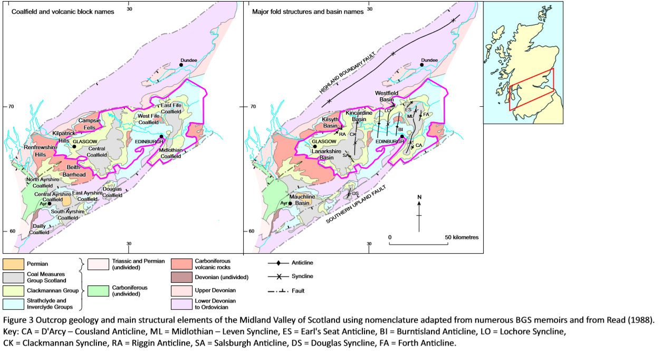

*Figure 4. Outcrop geology and main structural elements of the MVS using nomenclature adapted from GBS memoirs and from Read (1988). CA: D'Arcy – Cousland Ancline, ML: Midlothian – Leven Syncline, ES:Earl's Seat Ancline, BI: Burnsland Ancline, LO: Lochore Syncline, CK: Clackmannan Syncline, RA: Riggin Ancline, SA: Salsburgh Ancline, DS: Douglas Syncline, FA: Forth Ancline (Monaghan, 2014).*

## Magmatism

Magmatic activity in the MVS lasted for ~90 Ma (Upton et al. 2004), extending from the Carboniferous to Permian.

Early magmatic activity in the MVS occurred in the Pentland Hills (Lower Devonien, >400 Myr) in the form of lava flows and ash layers (basalt, andesite, trachyte and rhyolite) that are part of a large volcanic field. The Pentland Hills constitutes an intra-basin high in the MVS originally formed of Silurian sediments deposited 430-440 Myr ago (today highly metamorphosed and folded) in the closing Iapetus Ocean (see reversed Pentland Faults). Erosion since the end of the Ice age gave the Pentland Hills its current shape.

Early Carboniferous activity (Visean ~330-340 Myr) comprised basaltic to rhyolitic lavas, tuffs and related intrusions formed from short-lived volcanoes (e.g. Garleton Hills, Arthur’s Seat, Clyde Plateau Volcanic Fm). Those eruptions occurred in flood plain environment, resulting in the formation of explosive materials (ash, blocks). Later Visean and Namurian (~313-326 Myr) activity (e.g. Kinghorn and Bathgate Hills volcanic Fms) was dominated by basaltic lavas and tuffs (Smedley 1986, Stephenson et al. 2003, Upton et al., 2004).

In the late Carboniferous, short-lived extensional interval of tholeiitic magmatism extended across the MVS (Timmerman 2004, Monaghan & Parrish 2006), mostly occurring in the form of dolerite intrusive sills (e.g. Salisbury Crags) between sedimentary layers. Mantle xenoliths found in the Late Carboniferous layers have moreover been interpreted as evidences for a dextral strike-slip regime in the MVS during that period, as xenoliths originate from deep-seated sub-vertical fault zones able to transect the crust to tap a mantle source (Macintyre et al., 1981; Upton et al., 1983; Aspen et al., 1990). During the Permian, alkaline magmatism (Wallis 1989) related to post-orogenic extension was finally recognized across NW Europe, including in Scotland (Neumann et al. 2004).

Magmatism in the MVS influenced the basin structure in different ways. First, the large volume of magmatic material impact strongly the basin palaeogeography, forming locally significant proportion of the basin fill succession. During the Carboniferous, magmatism resulted in an increased heat flow in the western part of the Midland Valley, more volcanically active. Intrusive magmatism in the late Carboniferous finally locally enhanced sediment maturity up to ranks of Ro=6% within an approximately 300 m aureole of higher rank in the Sill Complex area.

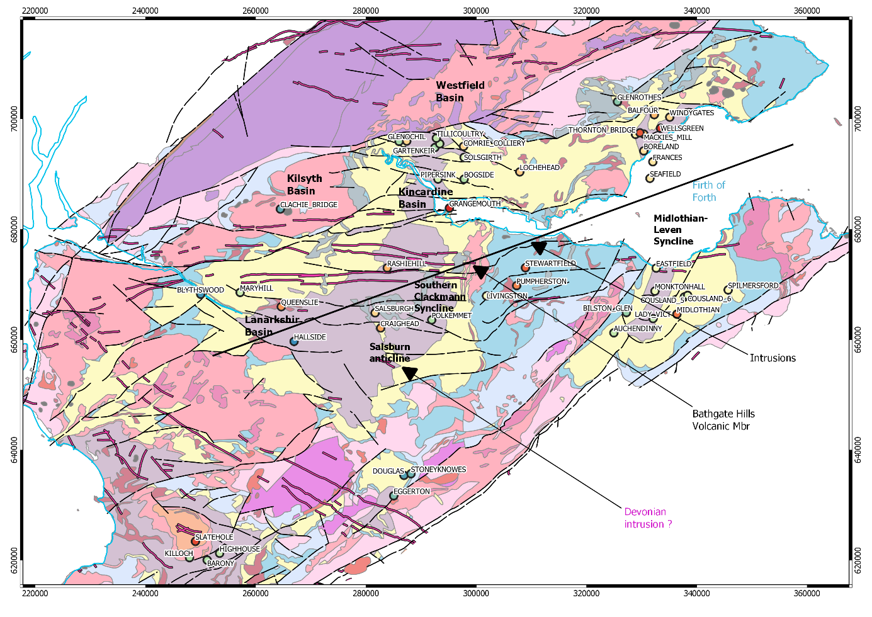

*Figure 5. BGS Data compilation (QGIS)*

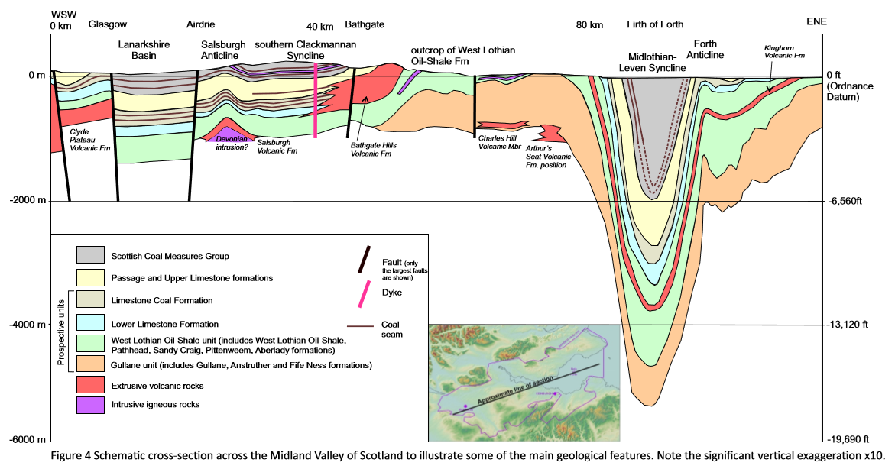

*Figure 6. Schematic cross-section across the Midland Valley of Scotland to illustrate some of the main geological features. Note the significant vertical exaggeration x10 (Monaghan, 2014).*

## Geophysical data

The magnetic anomaly map shows a high anomaly in the area of the Bathgate Hills Volcanic Formation, south from the Central Coalfield. This has been interpreted as the result of a large basic igneous mass extending to a depth of 5 km or more beneath overlying lavas, potentially separated from the basement by Devonian sedimentary and volcanic rocks (Rollin et al. 2009). Other volcanic centres (e.g. Campsie, Garleton and Burntisland) were also modelled as a lava pile over a deep intrusive source.

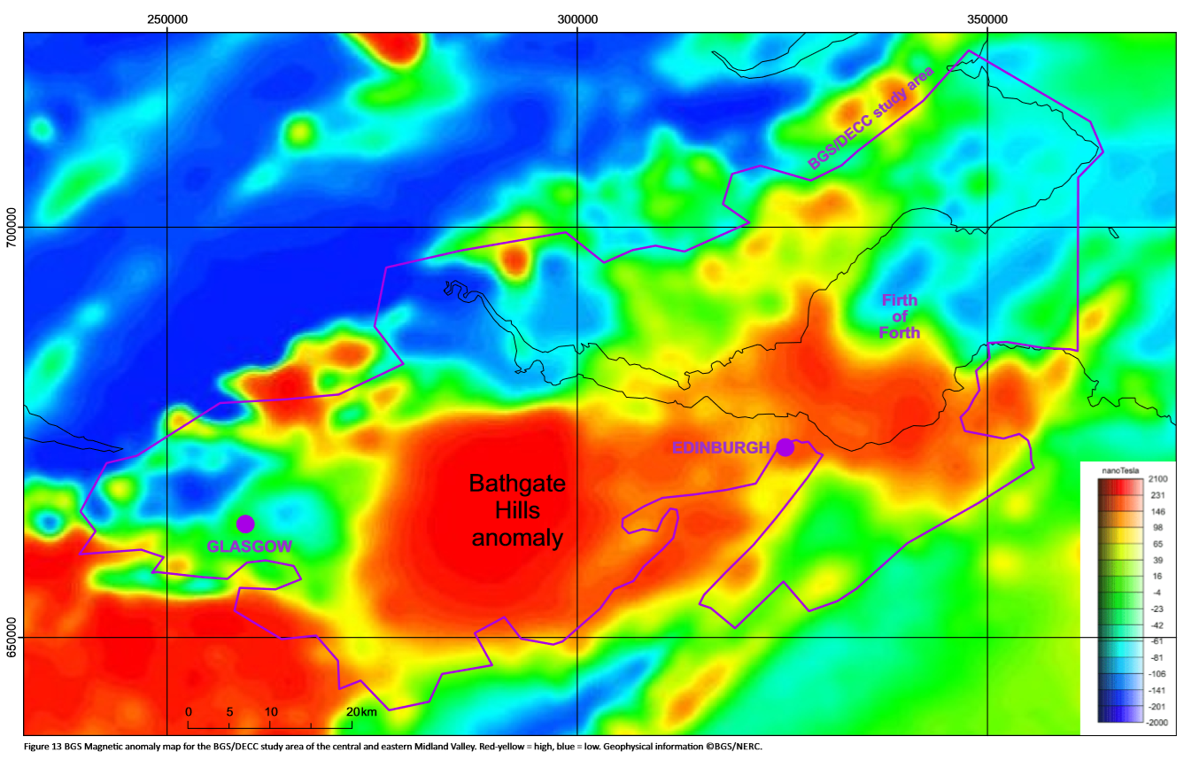

*Figure 7. BGS Magnetic anomaly map for the BGS/DECC study area of the central and eastern Midland Valley. Red-yellow = high, blue = low. Geophysical information ©BGS/NERC (Monaghan, 2014).*

Gravity anomalies suggest that an east-west basement horst extends from the Bathgate area to the Garleton Hills (East Lothian; Rollin et al. 2009). Both the Highland Boundary and Southern Upland faults can be observed in gravity and magnetic data, along with the position of the East and West Ochil Fault.

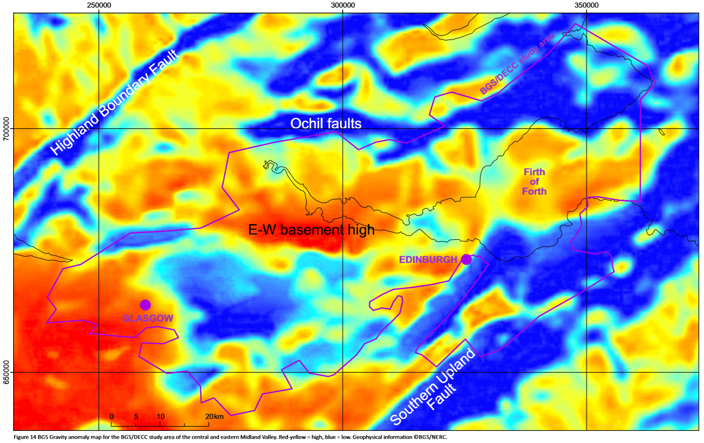

*Figure 8. BGS Gravity anomaly map for the BGS/DECC study area of the central and eastern Midland Valley. Red-yellow = high, blue = low. Geophysical information ©BGS/NERC (Monaghan, 2014).*

# Mine working

Mine water in abandoned mine workings represent a low temperature heat resource that can be used for i.e. space or domestic hot water heating, using Ground Source Heat Pump (GSHP) technology. Most of the abandoned mine workings in Scotland are former coal mines, which have been exploited since the 12th century. Underground mining was also used to a lower extent to extract ironstone, limestone, oil-shale, lead, gold, silver and other minerals.

## Coal and oil-shale bearing deposits

Most of the coal-bearing rocks located in the Midland Valley in Scotland are contained within the Carboniferous sediments. The thickness of coal seams typically ranges between 1 m (more common) and 3 m (in areas of greater deposition), depending on the thickness of the sedimentary cycle, with some exceptional seams reaching 15 m (Rippon, 2002). The formations of interest are:

* Scottish Coal Measures Group: Cyclical sandstone, siltstone, mudstone
  + Scottish Upper Coal Measures Formation: >3940 ft (>1200 m). Contain little usable coal.
  + **Scottish Middle Coal Measures Formation**: 1150 ft (350 m). Contains seatrock and coal.
  + **Scottish Lower Coal Measures Formation**: 790 ft (240 m). Contains seatrock and coal.
* Clackmannan Group:
  + Upper Limestone Formation: Cyclical limestone, mudstone, siltstone and sandstone, seatrock and coal, >1970 ft, (>600 m).
  + **Limestone Coal Formation (Namurian)**: Cyclical sandstone, siltstone and mudstone, seatrock and coal, >550 m thick. Rich in coal seams. CH4 released from coal seams in the western part of the Central Coalfield (e.g. Bedlay and Cardowan colleries).
  + Lower Limestone Formation: repeated upward-coarsening cycles of limestone, mudstone, siltstone and sandstone with minor seatrock and coal, 240 m thick.

Coal Measures Group strata are preserved in the centre of the synclines and basins, in a Carboniferous succession over 2 km thick in the Central Coalfield.

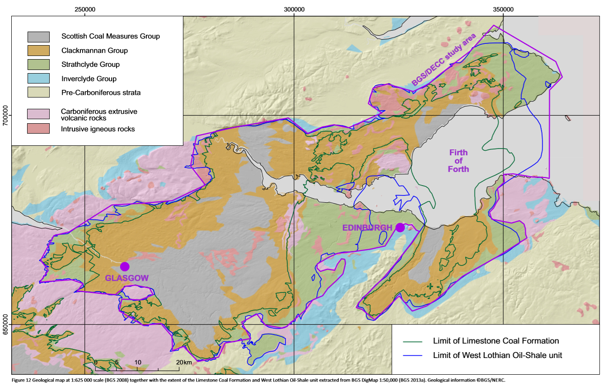

*Figure 9. Geological map at 1:625 000 scale (BGS 2008) together with the extent of the Limestone Coal Formation and West Lothian Oil-Shale unit extracted from BGS DigMap 1:50,000 (BGS 2013a). Geological information ©BGS/NERC (Monaghan, 2014).*

## Anthropogenically enhanced aquifers

|  |  |  |
| --- | --- | --- |
| Formation | Colliery | Flow rate |
| Limestone Coal Formation | Prestongrange Colliery [NT 373 737] | 40-75 l/s over 140 h/week at 165-225 m depth |
| Kilsyth Colliery [715 779] | 150 l/s at 206 m depth |
| Twechar Colliery [701 762] | 13 l/s for 12h/day ay 317m |
| Monktonhall Colliery, Midlothian | 35 l/s |
| Blindwells Colliery, East Lothian |  |
| Scottish Middle Coal Measures Formation | Bothwell Colliery [686 588 | 230 l/s at 396 m depth |
| Scottish Lower Coal Measures Formation | Polkemmet Colliery, West Lothian | 75 l/s |
| Frances Colliery, Fife | 120 l/s |
| Limestone Coal formation and/or Coal Measures | Falkirk District | 30-55 l/s |
| Blindwells Colliery, East Lothian | 315 l/s |

*Table 2. Historical mine dewatering rates (Gillespie et al., 2013)*

Carboniferous sedimentary strata in the MVS are generally described as moderately productive aquifers due to a relatively low rock permeability, providing borehole yields in the range 5-15 l/s (MacDonald et al., 2004; Robins, 1990; Ball, 1999). Mining activities resulted in an increase in permeability of those layers by increasing void space in zones where seams are mined out, but also through fracturing of competent horizons above mined seams (subsidence-related stressing), and though the remnant shafts and roadways. Those provide large diameter artificial flow pathways, characterizing mines as “anthropogenically enhanced aquifers” (Banks, 1997).

The creation of voids by mining activities moreover contribute to the formation of large rock-water surfaces within flooded abandoned workings, providing an increased potential for heat exchange (Banks et al., 2003; PB Power, 2004). Mine water temperatures for boreholes in the Midland Valley range from 12 to 21°C, with a mean/median of 17°C, with an average temperature of 8-15 °C for water circulating above 200 m depth (Robins, 1990). Despite the temperature of mine waters generally increases with depth according to the geothermal gradient, no correlation has been found between the depth of the measurements and the observed water temperature in the Midland Valley. Groundwater of different temperature may indeed enter the borehole at different depths, exchanging heat with the surrounding rocks to a degree that will depend on the flow rate, making it difficult to predict the temperature of the pumped watetr.

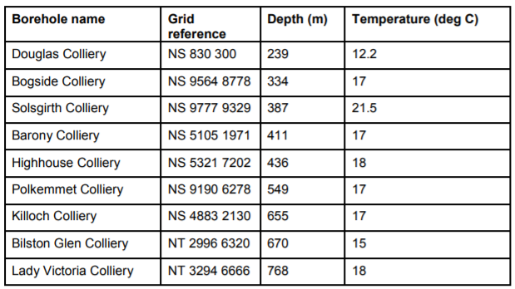

*Table 3. Temperature at mine boreholes (Gillspie et al., 2013)*

Earthquakes ≥ 2.5ML have been recorded in several locations within the Midland Valley of Scotland, with smaller events recorded in the coalfields (e.g. northern Central Coalfield and the Midlothian Coalfield) attributed to roof/pillar collapse (e.g. Ottemoller & Thomas 2007, Baptie 2010). Furthermore, the evidence that some limited seismicity (e.g. the Leadburn earthquake of 2007) occurs in the area at the present-day suggests that some of the major structures like the Southern Upland fault continue to take up regional strain (Underhill et al., 2008)

Source for seismic data: <ftp://seiswav.bgs.ac.uk/2019/GGERF>

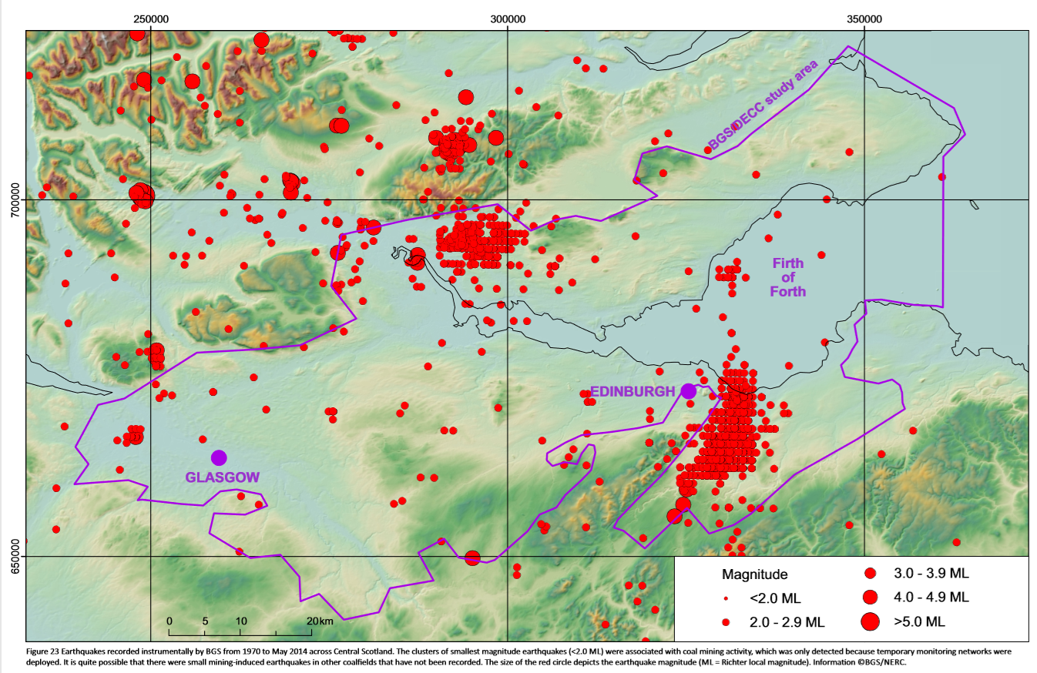

*Figure 10.* *Earthquakes recorded instrumentally by BGS from 1970 to May 2014 across Central Scotland. The clusters of smallest magnitude earthquakes (<2.0 ML) were associated with coal mining activity, which was only detected because temporary monitoring networks were deployed. It is quite possible that there were small mining-induced earthquakes in other coalfields that have not been recorded. The size of the red circle depicts the earthquake magnitude (ML = Richter local magnitude). Information ©BGS/NERC (Monaghan, 2014)..*

## Available data

* Coal Authority: <http://mapapps2.bgs.ac.uk/coalauthority/home.html>. 33 936 underground working polygons (with associated extent, depth, date and seam extraction data), 2,785 probable unrecorded working polygons and 11 637 spine roadways.
  + - <https://www.nrscotland.gov.uk/research/guides/coal-mining-records#CB>
    - <http://www.scottishmining.co.uk/377.html>
* BGS: GeoIndex Onshore:
  + - <http://mapapps.bgs.ac.uk/geologyofbritain/home.html>
    - <http://mapapps2.bgs.ac.uk/geoindex/home.html>
  + 1980 Environmental Geology Map 1:10 000
  + Locations of known adits and shafts in mined areas
  + Borehole database: dataset of all records in the BGS Single Onshore Borehole Index (SOBI: <http://www.bgs.ac.uk/products/onshore/SOBI.html>). Over 215,000 records in the Midland Valley of Scotland, 56 records >1,000 m and 289 >500 m drilled depth. 1-km deep wells in the centre of coalfields reach only the Upper Carboniferous coal-bearing strata (no deeper than the Limestone Coal Formation). In total, 98 hydrocarbon exploration and appraisal wells were drilled within the Midland Valley of Scotland between 1919 and 2008. BGS boreholes at Spilmersford, Rashiehill and Glenrothes have associated downhole geophysical data.

## Conceptual model

Unmined coal-bearing strata tend to form complex multi-layered minor aquifers, with vertical and lateral variations of low permeability layers (mudstone) interbedded with higher permeability layers (sandstone, limestone). Intrusions of igneous rock (dykes, sills, plugs) and faults also tend to compartmentalize these aquifers.

Durham Energy Institute at Durham University is conducting an assessment of mine energy potential at the local, regional and national scale, with the national research partnership for deep geothermal energy BritGeothermal. The following part summarizes their observations and results (Monaghan, 2019).

Mine-water heat systems are generally operated open-loop ground-source heat system. This consists in pumping the 12-20C water from the flooded mine shafts and galleries through boreholes, increasing the water temperature through heat pumps, and then reinjecting it into the subsurface.

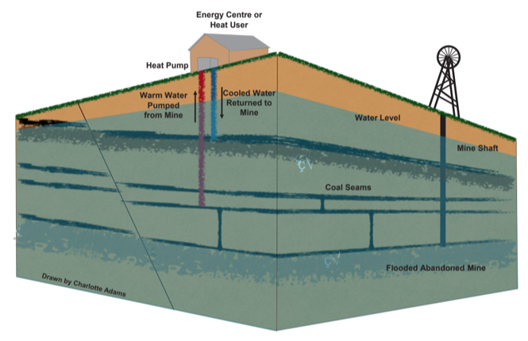

*Figure 11: Schematic Diagram of a mine water heat pump system (Drawn by Charlotte Adams)*

Following long periods of abandonment, mine waters tend to become stratified, with better-quality water generally lying above poorer-quality water (Nuttall & Younger, J. Contam. Hydrol. 2004). Pumping water from mine generally induces turbulence and mixing within the mine, leading to changes/reduction of the water quality with time and pumping rate (depending on the workings from which water is drawn from). Moreover, mine water generally contains a high concentration of iron, resulting from the interaction between the oxygenated mine-water and pyrite within the coal, which tends to precipitate when entering in contact with air.

State of the mines after abandonment:

* The shafts might be filled with rubble from demolished topside colliery infrastructure before being capped
* The galleries may be filled by collapsed roof material, leading to tunnels with partial blockages.
* Pumping was stopped in most mines and water levels have largely rebounded or are still rebounding. It may continue in some mines to prevent or minimise surface discharges of poor quality water.
* the amount of remnant void space depends upon the method of deep mining employed:
  + Early ‘room-and-pillar’ mining (small proportion of the total mining) involves working a grid, leaving pillars of coal intact for roof support and mining the areas between. This method is assumed to have around 50% of the void space remaining.

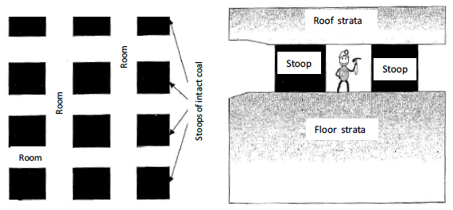

*Figure 12: Layout of stoop and room mine workings. Plan view on left and profile view on right. (Younger and Adams, 1999).*

* + Longwall mining (since 1950’): involves driving tunnels to the farthest extent of the mine, then removing coal from the seam laterally whilst retreating from the workings. The coal panel between the roadways is typically 100 to 250 m wide (Younger et al., 2002). This method allows the overburden above mined seams to collapse, forming ‘goaf’. There, only 20% of the original void space remains (Younger & Adams, Tech. Report 1999). Many areas formerly mined by the room-and-pillar method were latterly reworked using longwall extraction.

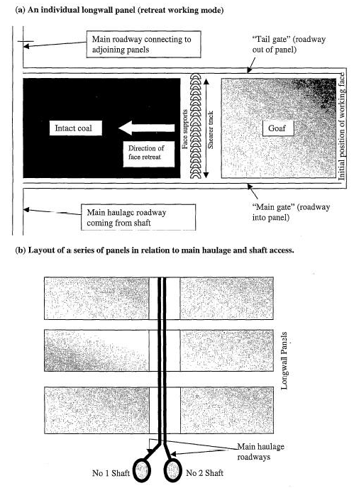

*Figure 13: Layout of typical longwall mine workings (Younger and Adams, 1999).*

Many shafts, roadways, drifts (see Younger et al., 2002) remain as open and interconnected voids in the subsurface. These voids form zones of high permeability in the workings, creating anthropogenically-enhanced aquifer (Banks, 1997) from which large yields can be obtained. The complex multi-layered nature of these mining-enhanced aquifers also allows to abstract water/heat from one depth interval and re-inject the used water at lower temperature to a different horizon, which increases the time for thermal breakthrough to occur.

In longwall mining, the mechanism of subsidence creates stresses in the overlying strata. Using typical longwall panel widths (W) of 100-250 m, 40-100 me of strata above the mined seam would be fractured due to the subsidence, enhancing the permeability of this volume of rock (Younger and Adams, 1999). The mined horizon is however likely to remain the most permeable zone even if containing broken goaf, with a porosity of ~30% (Younger and Adams, 1999). While intergranular flow would be dominant within the goaf horizon, fracture flow will dominate in the fractured zone above it, forming complex multi-layered aquifer.

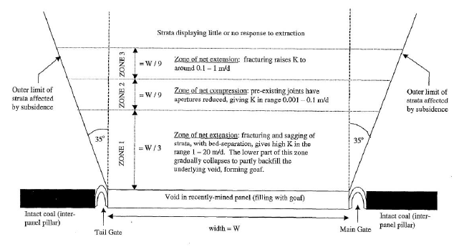

*Figure 14.* *Schematic diagram of the zones of extraction-related subsidence above a recently worked longwall panel (Younger and Adams, 1999).*

BritGeothermal is promoting new approaches to the national planning policy, licensing of heat and regulation of subsurface use to ensure that mine energy potential is considered when planning new developments. This group is also investigating the mine energy potential of a number of former coalfields. It is hoped that the Glasgow Geothermal Energy Research Field Site (BGS, 2018) will significantly reduce subsurface, geoscientific uncertainties and risks, raise awareness and stimulate the market for this low-carbon energy source.

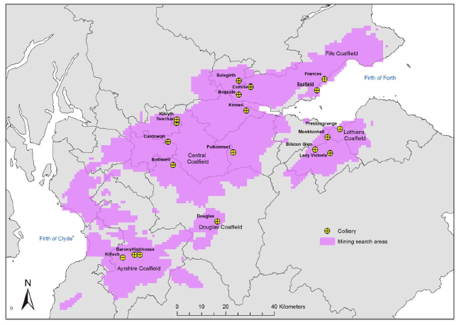

*Figure 15. Mineshafts in the MVS (Gillespie et al., 2013)*

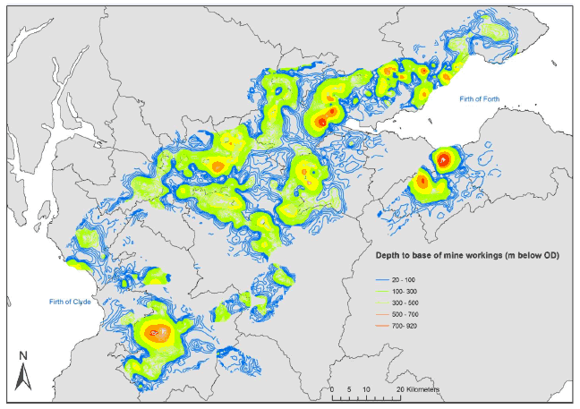

*Figure 16. Depth of mine workings viewed in GOCAD ® (©Paradigm) 3D modelling software, showing deepest workings in orange and red (Gillespie et al., 2013)*

# Existing projects

## UK <http://www.britgeothermal.org/projects/home.html>

### Minewater project, Glasgow, Scotland

The Glasgow Geothermal Energy Research Field Site is located on the western side of the central Coalfield of the MVS. Drilling of 12 boreholes in Dalmarnock and Rutherglen’s Cuningar Loop in Glasgow, on the site of the former Farme Colliery closed in 1921, to determine how much heat can be extracted from waters in abandoned mines beneath the city. The mine is located within 300 m of bedrock strata of the Scottish Upper, Middle and Lower Coal Measures formation. Data gathered since the first borehole was drilled in December 2018 includes temperature and water chemistry (UK Geoenergy Observatories Project). The aim is also to see how warm water moves around the abandoned mine workings over time and how much the mine workings from Glasgow down to the Lanarkshire coalfields remains interconnected.

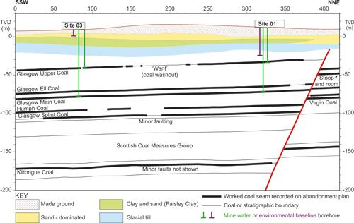

*Figure 17. Cross-section of the geology in the Cuningar Loop area with the planned borehole target depths shown, UK Geoenergy Observatory in Glasgow. Note that the thick black lines represent areas recorded on abandonment plans as mine workings. TVD=true vertical depth relative to Ordnance Datum, top X-axis is in metres*

See: <http://www.britgeothermal.org/projects/glasgowmw.html>

### Shettleston, Scotland

Shettleston uses water taken from 100 m depth from flooded coal mines. Water is heated to 55°C through a heat exchanger, to provide heat to 16 dwellings.

### Bilston Glen, Scotland

### Trailblazing project, Caerau, South of Wales

The scheme described as “trailblazing” would use underground mine water from the workings of the old Caerau colliery, which closed in the late 1970s, to heat houses, a school and a church in Caerau in the Llynfi Valley, South Wales.

Source : <http://home.bt.com/tech-gadgets/tech-news/welsh-valleys-village-geothermal-heating-mine-water-caerau-11364244392785>

Bridgend Council in Wales is working to deliver a larger district heating system that will initially supply heat to around 150 homes (Monaghan, 2019).

## Mieres, Asturias, Spain

The Vital Álvarez Buylla Hospital in Spain uses mine water from the abandoned and flooded Barredo-Santa Bárbara system of coal mines (Carboniferous in age) to supply energy for the heating and air conditioning system. Water pumped out of the Barredo mine shaft yields up to 3.5 MWt using heat exchanger system.

Source: <https://eurogeologists.eu/european-geologist-journal-43-viesca-geothermal-use-of-mine-water/>

## Marienberg, Germany

Water produced from a 144m deep shaft in Uranium mines.

## Heerlen, The Netherlands

Utilizes 5 wells drilled down to 700 m depth into coal mines to provide heat/cooling to 350 dwellings, commercial floor space and community buildings.

## Folidal mine, Norway

Cu, Zn and S mine produced until 1748.

Source: A. Hall et al. / Renewable and Sustainable Energy Reviews 15 (2011) 916–924

## USA

### Park Hill, Missouri

### Houghton, Michigan

In Houghton, mine water in pumped at the Keweenaw Research Center (KRC) from 300 feet below the surface.

Source : <https://www.mtu.edu/news/stories/2015/march/tapping-into-mine-water-for-geothermal-energy.html>

## Other projects

* Germany (Rhenish Massif region; Freiberg)
* Hungary (recsk mine)
* Norway (Kongsberg silver mine)
* Poland (Nowa Rudat coal mine)
* USA (Pittsburg coal mine)
* Canada (Con gold mine; Ropak Can Am Coal mine, Nova Scotia)

# Geothermal data

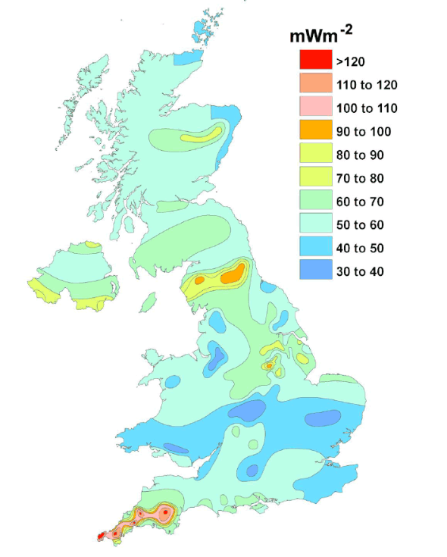

*Figure 18. Heat Flow in the UK (Gillespie et al., 2013)*

* Heat flow in Scotland (35 published heat flow values from onshore boreholes < 400 m depth, including 13 in the Midland Valley, collected in BGS Catalogue of Geothermal Data for the UK (Burley et al., 1984)):
  + 29-82 mW.m-2 (mean is 56 mW m-2 and the median is 57 mW m-2).
  + Apparent ‘hot spots' in the central part of the Midland Valley indicate a heat flow of 60 mW m-2 and of 70 mW -2 in the East Grampians region (granite intrusions).
* Average temperature gradient (temperature from 61 onshore boreholes < 1300 m depth in BGS Catalogue of Geothermal Data for the UK (Burley et al., 1984) and 133 BTH from 72 offshore wells in the North West Margin area (north of the Scottish mainland and west of the Orkney and Shetland islands) (Gatliff et al., 1996)):
  + 30 °C/km < 1.5 km (range between 3.7 and 45.0 ºC/km for onshore boreholes, with mean = 22.5 ºC/km and median =21.5 ºC/km)
  + 36 °C/km at 1.5-3.5 km
  + 47 °C/km > 3.5 km

The gradient for onshore data is defined mainly by boreholes in the Midland Valley. However, sedimentary basins such as the MVS commonly results from the stretching of the crust that might be thinner and thus display a higher heat flow relative to adjacent areas underlain by thicker crust. Only a few temperature data were acquired form crystalline rocks in onshore parts of Scotland (and none from > 300 m depth). However, 16 of the wells forming the North West Margin dataset terminated in the crystalline basement rocks that underlie the sedimentary cover, and thus, the bottom-hole temperatures (BHT) in these wells represent temperature data for crystalline rocks. The T-z trends shown below suggests that similar temperature is not dependent on the type of rock (crystalline basement or in sedimentary cover rocks).

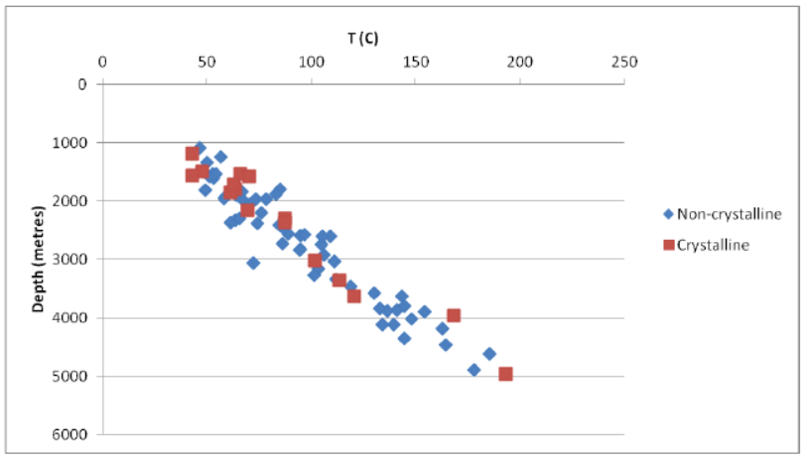

*Figure 19. BHT vs depth for offshore wells in the NW Margin (Gillespie et al., 2013)*

The geothermal gradient (figure below) has been defined by data from boreholes and wells that penetrate a range of rock types (crystalline and non-crystalline) and structural regimes (basin and ridge settings) both onshore and offshore, and is essentially continuous throughout the zone in which the deepest onshore data and shallowest offshore data overlap. This suggests the regional temperature gradient may be broadly the same in both settings (onshore and offshore). Moreover, the temperature range defined by the data at all depth is never greater than 46ºC. The limited scatter of the data, together with the broad geographical extent of the measurements and the continuity of the trend throughout the full 5 km depth, suggests that a consistent regional geothermal gradient exists beneath much of Scotland and remains unperturbed across the basement-cover interface. Thus, the temperature at any given depth down to 5 km could be predicted with a precision of approximately ±23 ºC.

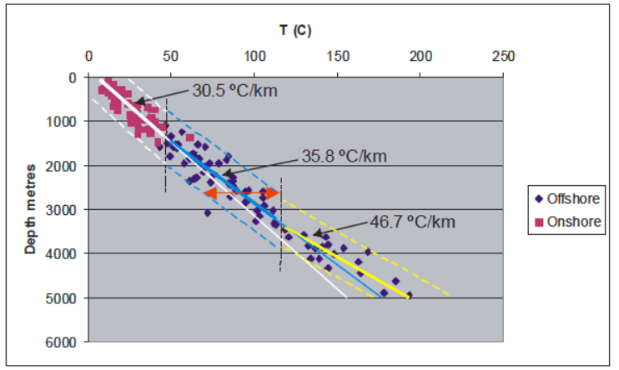

*Figure 20. Combined onshore and offshore BHT (Gillespie et al., 2013)*

Compaction of sedimentary rocks is likely to increase their thermal conductivity. This means that the geothermal gradient in sedimentary rocks should decrease with increasing depth if the heat flow profile is consistent.

|  |  |  |  |
| --- | --- | --- | --- |
| **Rock type** | **Character** | **K (W/m/K)** | **Reference** |
| sandstone | sedimentary | 3.3-4.9 | Lee et al., 1984 |
| mudstone | sedimentary | 1.5-2.2 | Lee et al., 1984 |
| limestone | sedimentary | 2.8-3.0 | Lee et al., 1984 |
| coal | sedimentary | 0.31 | Lee et al., 1984 |
| slate (metamudstone) | metamorphic | 2.7 | Lee et al., 1984 |
| basement metasediment | metamorphic | 3.51 | Lee et al., 1984 |
| basement metasediment | metamorphic | 3.1-3.5 | Wheildon et al., 1984 |
| granite | igneous | 3.0-3.5 | Wheildon et al., 1984 |
| granodiorite and tonalite | igneous | 2.5-2.9 | Wheildon et al., 1984 |
| dolerite and basalt | igneous | 2.2 | Lee et al., 1984 |
| peridotite | igneous | 2.2 | Wheildon et al., 1984 |

Several factors might also affect the surface temperature and thus a good estimation of the geothermal gradient:

* + Local source of heat (i.e. granite intrusions)
  + Topography
  + Recent climate change (cooling-warming cycles)
  + Trapped heat (low conductivity “cap” rock above a heat source
  + Heat refraction (i.e. inclined strata)
  + Convective heat transfer

While a thinner crust in offshore areas may account for a higher geothermal gradient in the deepest part of the curve, climate warming since the last glaciation may account for a lower geothermal gradient near the surface. Studies in the Canadian sedimentary basin have shown that heat flows were underestimated by 10-18% for wells shallower than 1 km due to the paleo-climatic effect, leading to an underestimation of the shallow geothermal gradient and thus in an underestimation of the heat resource at depth (Majorowicz et al., 2012). The significant change in surface temperature since the end of the ice age (cooler paleo-temperature at surface than present) indeed caused perturbation of the near surface < 2 km heat flow and a warming pulse that has propagated down to 2 km, expressed by a greater temperature gradient in the basement.

The post-glacial warming signal has been estimated in the order of 10 °C-15 °C (Gosnold et al., (2011). It is therefore important to take into consideration paleoclimatic corrections to heat flow data, using a sufficient number deep temperature profiles in equilibrium.

# Hot sedimentary aquifers

The geothermal potential of sandstone aquifers in the MVS (Devonian-carboniferous in age) has been investigated in the 80’ (Brown et al., 1987). Investigations highlighted the complexity of the geological structure of the MVS linked to the depositional environment (i.e. difficulty to extrapolate between boreholes due to diverse lithologies, presence of fault/intrusions, complex groundwater flow resulting from coal mines). The main HSA prospect, the ~170 m thick Knox Pulpit Sandstone Formation (Upper Devonian Stratheden Group), composed of weakly cemented wind-deposited sandstones, can be found at 4 km depth in the MVS (Gillepsie et al., 2013). Finally, most of the sandstone aquifers in the Carboniferous sediments (except the Passage Formation) are likely to present low geothermal potential due to the modest thickness of the strata, a low natural permeability and a restrictive geographical distribution. Permian and Triassic rocks are likely to represent the most productive aquifers.

Low permeability and low thermal conductivity volcanic rocks (basaltic and andesitic lavas and pyroclastic deposits) overlying sedimentary rocks in the MVS have been suggested to represent “cap rocks” to HSA systems , by trapping both heat and water in underlying sedimentary aquifers. Those include:

* Devonian basaltic and andesitic rocks under the Ochil Hills and Sidlaw Hills in the NE MVS and under the Carrick Hills and Pentland Hills in the SE MVS
* Carboniferous basaltic rock beneath Renfrewshire, Kilpatrick, Campsie and Gargunnock hills in the west and under the Garleton Hills in the east.

New and more detailed heat flow measurements (through the drilling of new inclined wells in those areas) would be necessary to identify potential thermal anomalies beneath igneous rocks. In addition, testing deep boreholes could be used to infer the actual permeability (and its change with depth) together with the overall productivity at depth to determine HSA potential.

# Hot Dry Rocks and HHP Granite

The regional “background” geothermal gradient calculated for Scotland in Gillepsie et al. (2013) suggests that a temperature of 150C would be reached at 4-5 km depth. However, this is limited by the lack of onshore temperature measured in crystalline rocks at a depth higher than 2 km. For HDR systems, it is of interest to identify local thermal anomalies at accessible depth (i.e. additional heat generated in situ, trapped heat).

High Heat Production (HHP) granite intrusions (with an estimated minimum capacity of 4.0 μW m-3) are likely to be the only source of additional in-situ heat generated beneath Scotland, while only low-conductivity rocks are likely create situations where the vertical upflow of heat is trapped at depth (see HSA section).

The largest and greatest concentration of intrusions is located in the block of crystalline rocks bounded by the Highland Boundary Fault and the Great Glen Fault. Only granite (sensus stricto) intrusions contains sufficient concentration of K,T and U element to generate heat by radioactive decay that would have a geothermal significance. Those granite intrusions occured during different events:

* < 10% occured during crustal stretching that preceded/accompanied the opening of the Iapetus Ocean, ~600 million years ago. Those intrusions can be found in the Grampian Highlands and Northern Highlands, and are unlikely to have HHP character (small and chemical composition not favorable).
* Most of granitic intrusions were formed in association with the Caledonian Orogeny (closure of the Iapetus Ocean) between 500-400 Ma ago
  + the Grampian Event (c. 490–460 Ma) produced several large bodies of granite/ granodiorite south of Inverness and near Aberdeen, with low HP values (0.6–2.2 μW m-3).
  + The Scandian Event (c. 435–420 Ma) produced numerous intrusions of granite, granodiorite and diorite, mostly in the Grampian Highlands region. HP values for granite *sensus stricto* ranges from 2.2 to 7.3 μW m-3, with the mean HP values for 8 of them (the Helmsdale, Fearn, Abriachan, Bennachie, Mt Battock, Ballater, Cairngorm and Monadhliath intrusions) being >= the threshold for HHP character (4 μW.m-3)
  + Two large intrusions (Fleet and Criffel), with HP values of 3 and 2.2 μW m-3 were emplaced in the southern Scotland, at the end of the Caledonian Orogeny (c. 410–390 Ma).

“*The Midland Valley represents the largest onshore area in Scotland where a thick pile of sedimentary rocks overlies crystalline basement. The sedimentary strata in places contain numerous seams of coal, which has very low thermal conductivity and so is an excellent thermal insulator. The coal seams are, however, very thin compared to the interbedded mudstones and sandstones that will mainly determine the thermal conductivity profile, and the degree to which they would act as a thermal insulator is not clear. The nature of the basement rocks beneath the Midland Valley is very poorly understood, and the extent to which intrusions of granite (let alone HHP granite) might exist in them is not known, and may be impossible to determine. Only one intrusion of granitic rock of significant size actually crops out within the Midland Valley; the* ***Distinkhorn intrusion*** *(Figure 26) consists of diorite and granodiorite, and has low HP capacity (2.0 μW m-3). The potential for locating and exploiting a hot buried granite in the Midland Valley therefore appears to be very small; however, if granite intrusions do exist in the basement rocks, the heat they supply to the overlying sedimentary rocks may contribute to the geothermal energy potential in Hot Sedimentary Aquifer settings and abandoned mine workings*.“ (Gillespie et al., 2013)

Low thermal conductivity rocks such as basaltic and andesitic lavas (with values of ~ 2.2 W/m.K in the Midland Valley) have a potential to embody large heat reservoirs (elevated temperatures compared to other rock types) in order to maintain consistent geothermal gradient. This effect is particularly enhanced if the supply of heat from depth exceeds normal background values (i.e. residual heat from magmatism). The low thermal conductivity of basic (silica-poor) igneous rocks forming large intrusions in Aberdeenshire (e.g. Morvern-Cabrach, Insch and Huntly-Knock intrusions), means they may be hotter than rocks of higher thermal conductivity in the same area. Those intrusions are interpreted to overlie the East Grampians Batholith (part of which consists of HHP granite), with their bases at between 1 and 5 km depth, which might provide a boost to background heat flow in the area.

# Brainstorming

## Key points / Objectives

* Determine where the heat comes from: what are the main sources of heat beneath MVS, what controls the mine water temperature, what has the main influences (i.e. rock type, faults, fluid flow?)
* Understand how heat is distributed laterally and vertically
* Identify the main heat transfer processes (conductive/convective?)
* Develop a numerical tool to predict heat in mines and estimate total heat available
* Identify the best locations for heat extraction/reinjection, sustainable heat production rate

## Proposed methodology

* Calculate the Volume (%) of rock type in the MVS (statistical analysis) and compare to mine water T°
* Analyze U, Th, K composition of basement rocks to calculate the %heat produced by radioactive decay
* Determine rock properties (i.e. permeability, storativity) of Carboniferous mined rocks (pumping test?)
* Identify type of porosity: pore/fracture porosity, induced fractures, shaft/roadways/galleries…
* Increase accuracy of heat flow in the MVS by increasing spatial density of temperature measurements on surface and at depth (bottom-hole temperature, BTH) + extend BTH versus depth (T-z) dataset to include unpublished data held by the Department of Energy & Climate Change (DECC)
* Create a heat flow model corrected for the effect of post-glacial warming on the shallowest part of the geothermal gradient, to better identify potential ‘hot spots’ and determine size of heat source (i.e. see thermal response tests TRT)
* InSAR analysis of ground displacement to identify areas with uplift (i.e. zones with more water recharge)
* Compare geophysical data (magnetic, gravity, seismic, InSAR) with mine workings/roads/shafts and fault maps to identify main flow paths 🡪 where does conductive/convective heat transfers dominate?
* Look at water geochemistry, exothermic reactions, acid mine workings, sulfide reduction + thermogenic origin of methane (CBM, CMM) and other gases produced in the MVS: *“The Scottish CBM contains a resolvable mantle He, Ne and Ar contribution that may originate from melts in the deep crust.” (Gyore et al., 2017)*
* Identify the source pathway receptors
* Look at glacial input
* Model thermal breakthrough due to reinjection of colder mine water + estimate best reinjection depth + calculate how much heat could be produced at a sustainable rate.

# Data required

* Surface temperature and borehole temperature (BHT)
* In situ rock conductivity measurements using TRT (i.e. Raymond, J. INRS)
* Rock samples (for chemical and petrophysical analysis / thermal properties definition)
* Data on the number and thickness of seams mined, and of the locations of shafts and roadways in the vicinity. BGS has already compiled much of this information for Glasgow (Campbell, 2010). Data for other parts of the Midland Valley are available digitally from the Coal Authority, or in paper or scanned image form from BGS.
* Pumping tests (determine hydraulic properties of rock + working connections)?
* Current remediation schemes for the mines (pumped or not?)
* Evaluation of the amount of collapsed materials / goaf + flooded / groundwater level
* Request **abandonment plans** for seams within the collieries worked to calculate the worked areas + seam thickness:
  + <https://data.gov.uk/dataset/669a294f-e322-499b-9eae-775455c7c8d8/digitised-mine-plan-data-from-the-midland-valley>
  + <https://data.gov.uk/dataset/54d0c0a2-995c-440f-a10b-eaf93a3e8fad/plans-of-abandoned-mines-coal-oil-shale-for-scotland-held-on-microfilm>
  + <https://ukgeos.ac.uk/data-downloads/glasgow/bedrock-mine>

# References

Adams, C., Monaghan, A. & Gluyas, J., Mining for heat. *Geoscientist* **29 (4)**, 10-15, 2019. <https://doi.org/10.1144/geosci2019-021>*.*

Busby, J. Heat energy beneath Glasgow. British geological Survey. Available on: <https://www.bgs.ac.uk/research/energy/geothermal/heatEnergyGlasgow.html>

B. M. Freifeld, S. Finsterle, T. C. Onstott, P. Toole, and L. M. Pratt, 2008. Ground surface temperature reconstructions: Using in situ estimates for thermal conductivity acquired with a fiber-optic distributed thermal perturbation sensor. GEOPHYSICAL RESEARCH LETTERS, VOL. 35, L14309, doi:10.1029/2008GL034762

Gillespie, M.R., Crane, E.J, Barron, H.F., 2013. Study into the Potential for Deep Geothermal Energy in Scotland, Scottish Government Project. AECOM, BGS. Number: AEC/001/11

Hall, A et al. Geothermal energy recovery from underground mines. Renewable and Sustainable Energy Reviews 15 (2011) 916–924

Loredo, C et al. Modelling flow and heat transfer in flooded mines for geothermal energy. International Journal of Coal Geology 164 (2016) 115–122

Majorowicz et al., 2012. Implications of Post-Glacial Warming for Northern Alberta Heat Flow – Correcting for the Underestimate of the geothermal Potential.

Marquez, M.I.V., Raymond, J. Terrestrial heat flow evaluation from thermal response tests combined with temperature profiling. In: Physics and Chemistry of the Earth

Monaghan, A.A. 2014. The Carboniferous shales of the Midland Valley of Scotland: geology and resource estimation. British Geological Survey for Department of Energy and Climate Change, London, UK.

Todd, F., Mcdermott, C., Fraser Harris, A., Bond, A., Gilfillam, S., 2019 (accepted manuscript). Coupled hydraulic and mechanical modelling of surface uplift due to mine water rebound: implications for mine water heating and cooling schemes. https://doi.org/10.1144/sjg2018-028

J. Raymond, R. Therrien. Low-temperature geothermal potential of the ﬂooded Gasp´e Mines, Quebec, Canada. Geothermics 37 (2008) 189–210

J.R. Underhill et al. Controls on structural styles, basin development and petroleum prospectivity in the Midland Valley of Scotland. Marine and Petroleum Geology 25 (2008) 1000–1022

UK Geoenergy:

<https://ukgeos.ac.uk/observatories/glasgow>

<https://www.bgs.ac.uk/ukgeoenergyobs/home.html>

Coal Authority: <https://www.gov.uk/government/organisations/the-coal-authority>

GIS Data Sources:

<https://www.bgs.ac.uk/products/digitalmaps/digmapgb_625.html>

<https://www.bgs.ac.uk/products/hydrogeology/maps.html>

<https://www.bgs.ac.uk/data/gravAndMag.html>

<https://www.bgs.ac.uk/research/ukgeology/nationalGeologicalModel/gb3d.html>

Slideshares:

<https://www.slideshare.net/JasminRaymond/new-methods-to-spatially-extend-thermal-response-test-assessments>

<https://www.slideshare.net/MartinPreene/geothermal-energy-in-mining>

# Appendices

|  |  |  |  |  |  |  |  |
| --- | --- | --- | --- | --- | --- | --- | --- |
| **Borehole name** | **Region** | **Grid reference** | **Source** | **Depth** | **Temp** | **DT** | **Type** |
| Rashiehill | West Midland Valley | NS 8386 7301 | BGS | 964 | 34.4 | 26.2 | LOG |
| Clachie Bridge | West Midland Valley | NS 6447 8368 | BGS | 300 | 13.2 | 16.0 | LOG |
| Salsburgh | West Midland Valley | NS 8166 6486 | GAS | 883 | 30.0 | 24.1 | BHT |
| Hallside | West Midland Valley | NS 6694 5975 | BGS | 350 | 11.8 | 6.0 | LOG |
| Grangemouth | West Midland Valley | NS 9513 8387 | NCB | 1134 | 45.0 | 30.9 | BHT |
| South Balgray | West Midland Valley | NS 50 75 | BEN | 160 | 15.3 | 45.0 | EQM |
| Blythswood | West Midland Valley | NS 5003 6823 | BEN | 105 | 12.0 | 37.1 | EQM |
| Douglas Colliery | West Midland Valley | NS 830 300 | NCB | 239 | 12.2 | 14.2 | MWT |
| Solsgirth Colliery | West Midland Valley | NS 9777 9329 | NCB | 387 | 21.5 | 31.0 | MWT |
| Bogside Colliery | West Midland Valley | NS 9564 8778 | NCB | 334 | 17.0 | 22.2 | MWT |
| Highhouse Colliery | West Midland Valley | NS 5321 7202 | NCB | 436 | 18.0 | 19.5 | MWT |
| Barony Colliery | West Midland Valley | NS 5105 1971 | NCB | 411 | 17.0 | 19.0 | MWT |
| Killoch Colliery | West Midland Valley | NS 4883 2130 | NCB | 655 | 17.0 | 11.9 | MWT |
| Polkemmet Colliery | West Midland Valley | NS 9190 6278 | NCB | 549 | 17.0 | 15.5 | MWT |
| Eggerton | West Midland Valley | NS 8504 3171 | NCB | 410 | 14.0 | 13.2 | BHT |
| Tillicoultry | West Midland Valley | NS 9276 9653 | NCB | 510 | 18.0 | 15.9 | BHT |
| Tullibody | West Midland Valley | NS 8601 9594 | NCB | 325 | 16.0 | 18.8 | BHT |
| Cartlove | West Midland Valley | NS 9403 9267 | NCB | 404 | 16.6 | 16.3 | BHT |
| Gartenkeir | West Midland Valley | NS 9267 9486 | NCB | 488 | 16.0 | 15.0 | BHT |
| Shannock Hill | West Midland Valley | NS 9338 9512 | NCB | 497 | 18.0 | 19.9 | BHT |
| Pipersink | West Midland Valley | NS 9307 8911 | NCB | 408 | 20.2 | 25.5 | BHT |
| Glenochill | West Midland Valley | NS 8769 9617 | NCB | 628 | 30.0 | 32.0 | BHT |
| Queenslie | West Midland Valley | NS 6466 6598 | NCB | 691 | 36.0 | 38.4 | BHT |
| Slatehole | West Midland Valley | NS 4906 2342 | NCB | 1024 | 40.0 | 29.8 | BHT |
| Gallowknowe | West Midland Valley | NS 8388 3118 | NCB | 1261 | 37.5 | 22.8 | BHT |
| Stoneyknowes | West Midland Valley | NS 8817 3570 | BGS | 277 | 13.5 | 18.1 | BHT |
| Craighead | West Midland Valley | NS 8267 6212 | TAW | 977 | 35.0 | 27.2 | BHT |
| Maryhill | West Midland Valley | NS 5718 6856 | IC6 | 303 | 20.0 | 34.0 | EQM |
| Comrie | West Midland Valley | NS 9787 9501 | NCB | 850 | 30.0 | 24.1 | VST |
| Glenrothes | East Midland Valley | NO 2561 0314 | BGS | 279 | 14.4 | 28.1 | EQM |
| Balfour | East Midland Valley | NO 323 003 | BEN | 1205 | 33.4 | 19.8 | EQM |
| Windygates | East Midland Valley | NO 3510 0034 | NCB | 1298 | 30.0 | 16.1 | BHT |
| Spilmersford | East Midland Valley | NT 4570 6902 | BGS | 877 | 27.8 | 20.9 | BHT |
| Midlothian | East Midland Valley | NT 363 647 | ESO | 747 | 37.8 | 39.1 | LOG |
| Birnieknowes | East Midland Valley | NT 7580 7317 | BGS | 372 | 23.9 | 39.2 | LOG |
| Marshall Meadow | East Midland Valley | NT 9797 5686 | IC5 | 227 | 11.5 | 10.6 | EQM |
| Cousland No.5 | East Midland Valley | NT 3774 6773 | BP | 585 | 17.8 | 15.0 | BHT |
| Cousland No.6 | East Midland Valley | NT 3835 6801 | BP | 582 | 23.9 | 25.6 | BHT |
| Pumpherston | East Midland Valley | NT 0733 6979 | BP | 1175 | 36.7 | 23.3 | BHT |
| Lochead | East Midland Valley | NT 3219 9659 | NCB | 1167 | 30.4 | 17.7 | BHT |
| Boreland | East Midland Valley | NT 3040 9420 | AND | 1007 | 29.8 | 20.1 | EQM |
| Mackies Mill | East Midland Valley | NT 3050 9795 | NCB | 960 | 33.3 | 24.6 | BHT |
| Thornton Bridge | East Midland Valley | NT 2889 9722 | NCB | 665 | 28.0 | 27.5 | BHT |
| Thornton Farm | East Midland Valley | NT 2969 9761 | NCB | 1055 | 38.0 | 26.8 | BHT |
| Eastfield | East Midland Valley | NT 3264 7297 | NCB | 1028 | 26.0 | 15.6 | BHT |
| Bilston Glen Colliery | East Midland Valley | NT 2996 6320 | NCB | 670 | 15.0 | 8.7 | MWT |
| Lady Victoria Colliery | East Midland Valley | NT 3294 6666 | NCB | 768 | 18.0 | 10.8 | MWT |
| Auchendinny | East Midland Valley | NT 2496 6125 | NCB | 459 | 18.0 | 19.6 | BHT |
| Wellsgreen | East Midland Valley | NT 3342 9833 | NCB | 1485 | 42.3 | 22.0 | LOG |
| Livingston | East Midland Valley | NT 018 691 | OX3 | 640 | 27.0 | 28.1 | EQM |
| Stewart | East Midland Valley | NT 3633 6476 | LAS | 942 | 37.9 | 34.9 | BHT |
| Frances | East Midland Valley | NT 3214 9050 | NCB | 841 | 29.0 | 23.8 | VST |
| Monktonhall | East Midland Valley | NT 3242 7053 | NCB | 866 | 25.5 | 18.2 | VST |
| Seafield | East Midland Valley | NT 3150 8923 | NCB | 789 | 29.0 | 25.3 | VST |

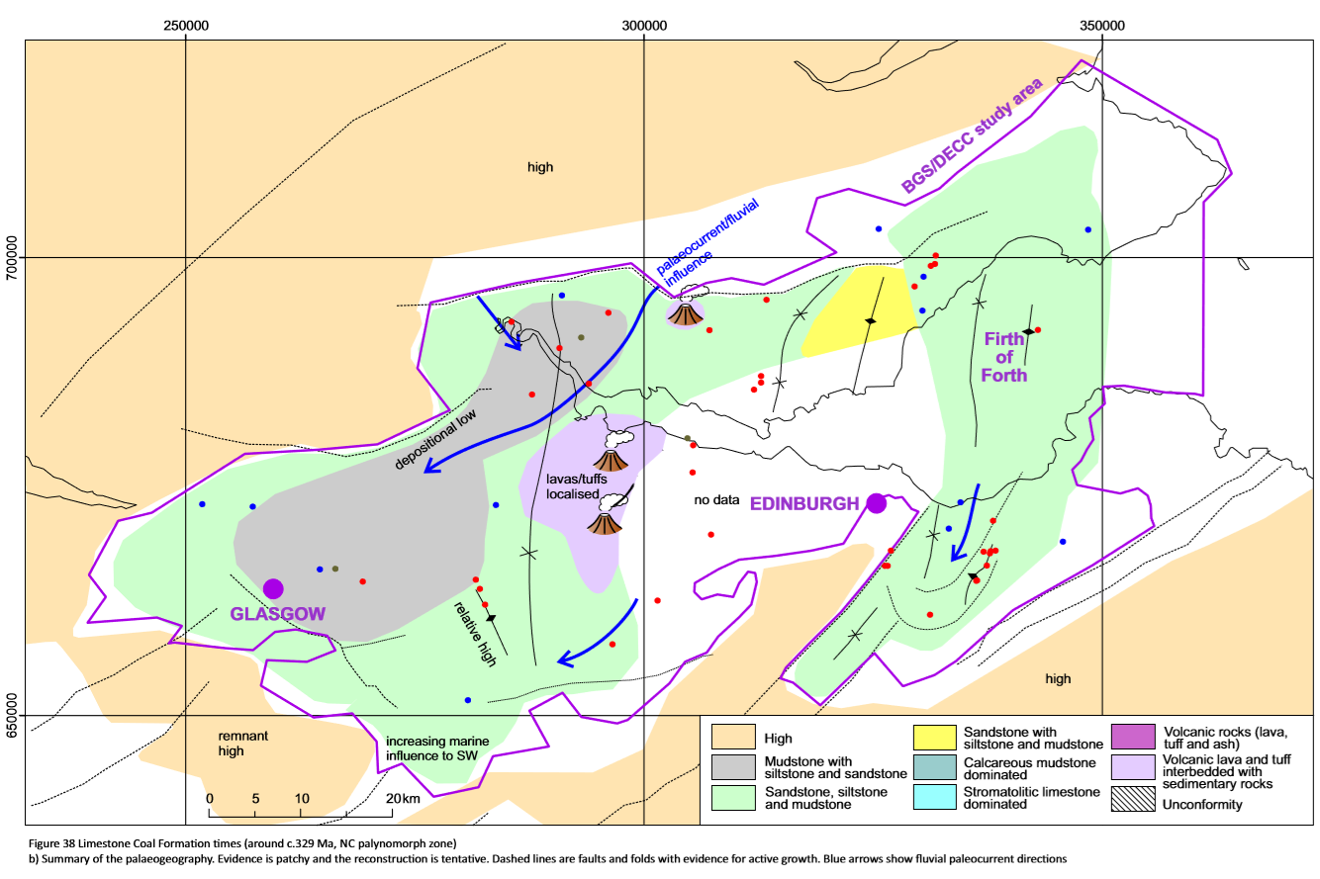

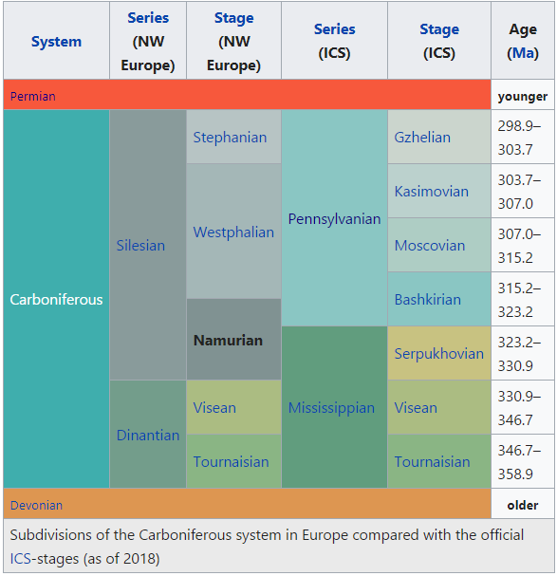

Methodology used to apply Paleoclimatic Correction on shallow temperature (Majorowicz et al., 2012)?

* Use equilibrium temperature logs (i.e. reaching a depth below the influence of the postglacial warming).
* Create models of conductivity and heat production: extrapolate up to the surface gradient and heat flow determined by linear fit of the measured curve
  + Heat flow = product of the mean gradient in the layer (i.e. 21 K/km) and thermal conductivity assumed for the corresponding layer rock (i.e. granite 2.7 W/(m K)).
  + Use proper rock conductivity values for sediments (i.e. 2.4 and 2.7 W/(m K)). Those are increased by a factor of 1.62 (frozen/melted conductivity ratio: 3.4/2.1 = 1.62) in the assumed permafrost zone close to the surface).
* Mean heat production in granite, 3-4 µW/m3 (based on Gamma spectral log (U TH K channels).
* Inversion of the measured T-z profiles in granites between 550 m – 2320 m using estimates of thermal conductivity (TC) and diffusivity of 1.44 * 10-6 m2/s, calculated according the formula:

Diffusivity (10-6 m2/s)=0.503*TC+0.0839

* Use corrected surface and deep temperatures to calculate corrected geothermal gradient (gradT)
* Estimate thermal conductivity of rocks with depth. Lower thermal conductivities in the deep basin results generally result from the combination of 1) higher % of low conductivity rocks and 2) a decrease in thermal conductivity of rocks with increasing temperature, that generally leads to higher geothermal gradients

Heat flow at depth z is therefore:

Q = Qrc+TCz x grad(Tz)

where Qrc = heat flow correction (mW/m2); grad (Tz)= uncorrected geothermal gradient effected by to the post-glacial warming at depth z.

Marquez et al (in review) inferred near-surface terrestrial heat flows combining subsurface thermal conductivity estimated from thermal response tests (TRT) in ground heat exchangers of 100 m depth and undisturbed temperature profiling in the same boreholes. The measured undisturbed temperature profiles corrected for Quaternary paleoclimatic effects were reproduced by numerical inversion of simulated conductive heat transfer. The optimization of the bottom boundary condition of the model (constant basal heat flow) was used to determine the near-surface heat flow. Historical surface temperature varying with time was used to constrain the upper boundary of the model to take into account the climate warming of the last century. Air temperature measurements Tamb were considered and converted to ground surface temperature Tg using the relationship developed by Ouzzane et al. (2015), defined as

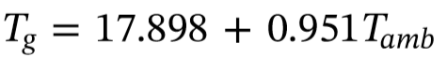

1. In situ thermal conductivity assessment: measure of sub-surface <100 m thermal conductivity profile measured using TRT.
2. Temperature profiles measurements (in same boreholes as TRT), logged with a submersible temperature and pressure data logger (RBRduet) – spatial resolution of 1-2 m and t resolution of 0.002C.
3. Paleoclimate correction: The initial temperature measured in the ground heat exchangers before conducting the TRT was corrected for the influence of the paleoclimate temperature variations due to the last Quaternary glaciations at each depth z. This correction depends on the duration of the glacial periods t1/t2, the temperature drop with respect to the present surface average temperature T1 and the thermal diffusivity α (m2/s) of the rocks (Jessop, 1990). Tm(K) is the T measured at depth z.

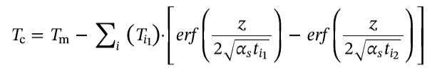

The paleoclimate correction of the measured temperature profiles resulted in an increase of the temperature at depth.

# Additional Materials



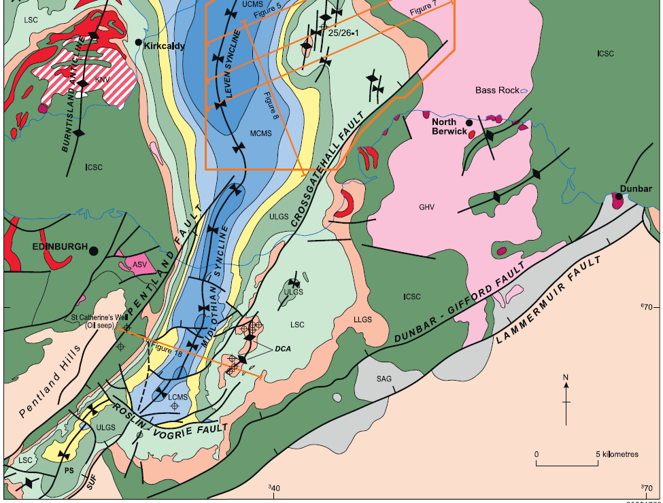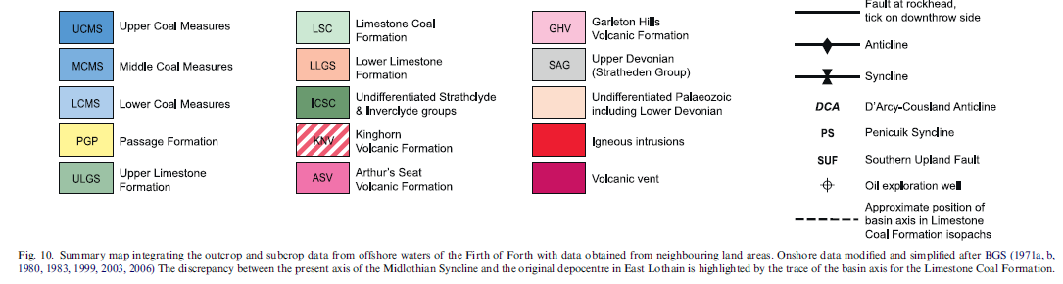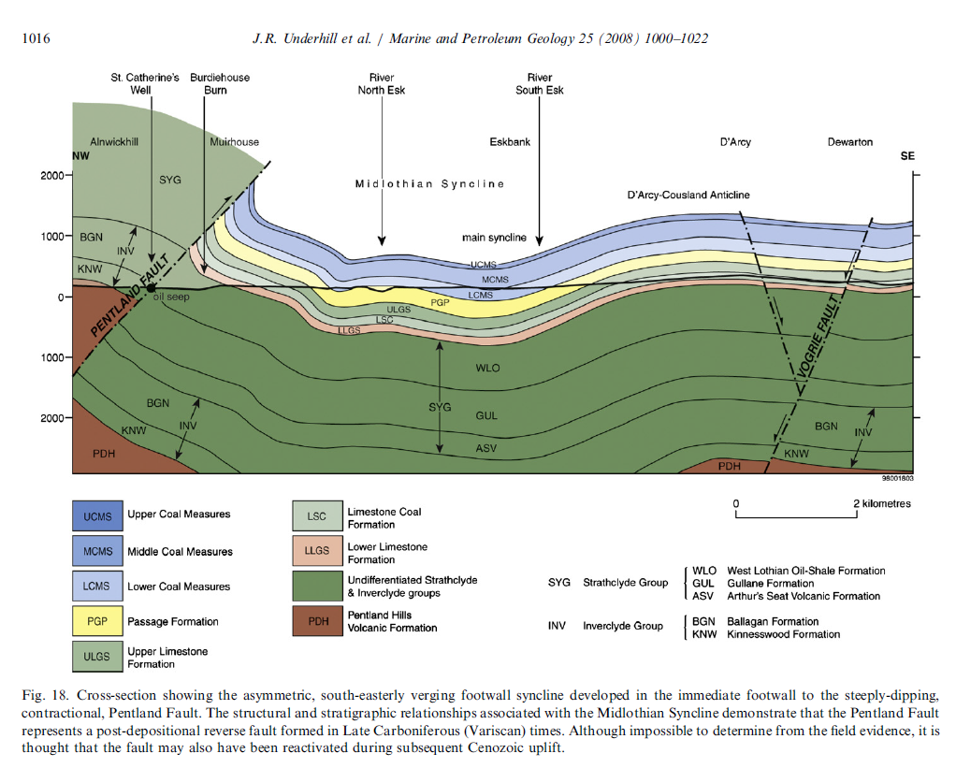

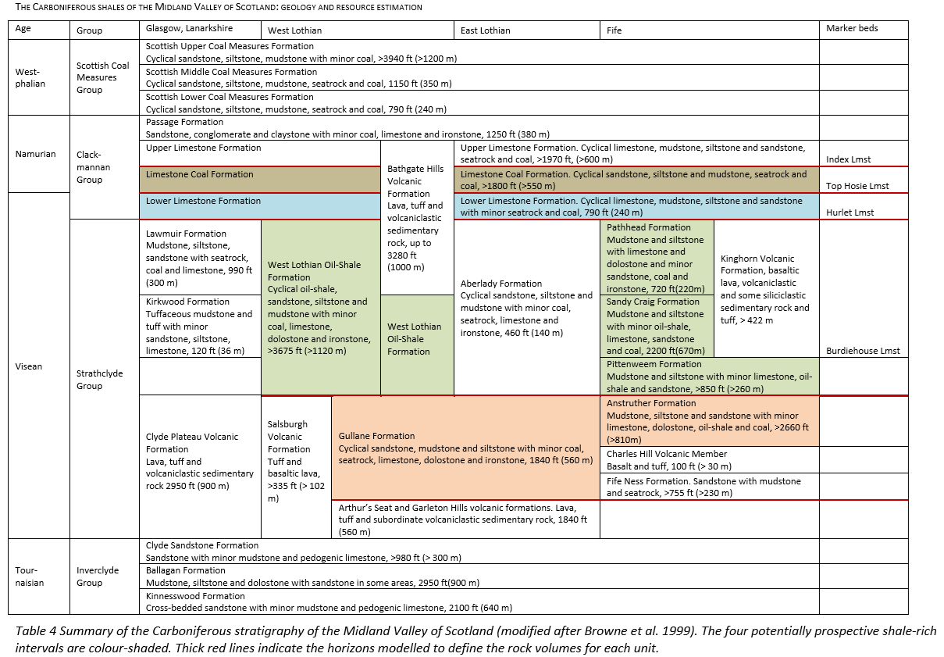

The 560 m thick Gullane Formation (Mitchell & Mykura 1962) consists of a cyclical sequence of fine- to coarse-grained sandstone interbedded with mudstone and siltstone, some beds of coal, seatrock, ostracod-rich limestone/dolostone, sideritic ironstone and rarely, marine beds with restricted faunas. The depositional environment was predominantly fluvio-deltaic, into lakes that only occasionally became marine (Browne et al. 1999). In Leven Seat 1, the Gullane Fm is interbedded within volcanic rock. Further west, the unit is missing by unconformity or replaced by volcanic rocks. In Straiton 1, the Fm is dominated by mudstone, whereas in Carrington 1 and Stewart 1, the Fm is more heterolithic. Over 800 m of Gullane Fm is seen in Pumpherston 1, against 560 m further east. The equivalent Anstruther Formation is present at depths of over 1,900 m in the Firth of Forth 1 and Milton of Balgonie 1 wells. Reconstruction of a palaeogeography indicates a heterolithic fluvio-deltaic succession sourced from the north-east, interbedded with localised volcanic rocks.

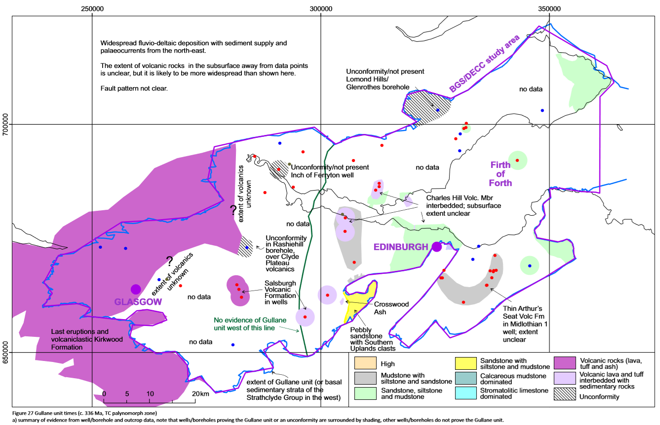

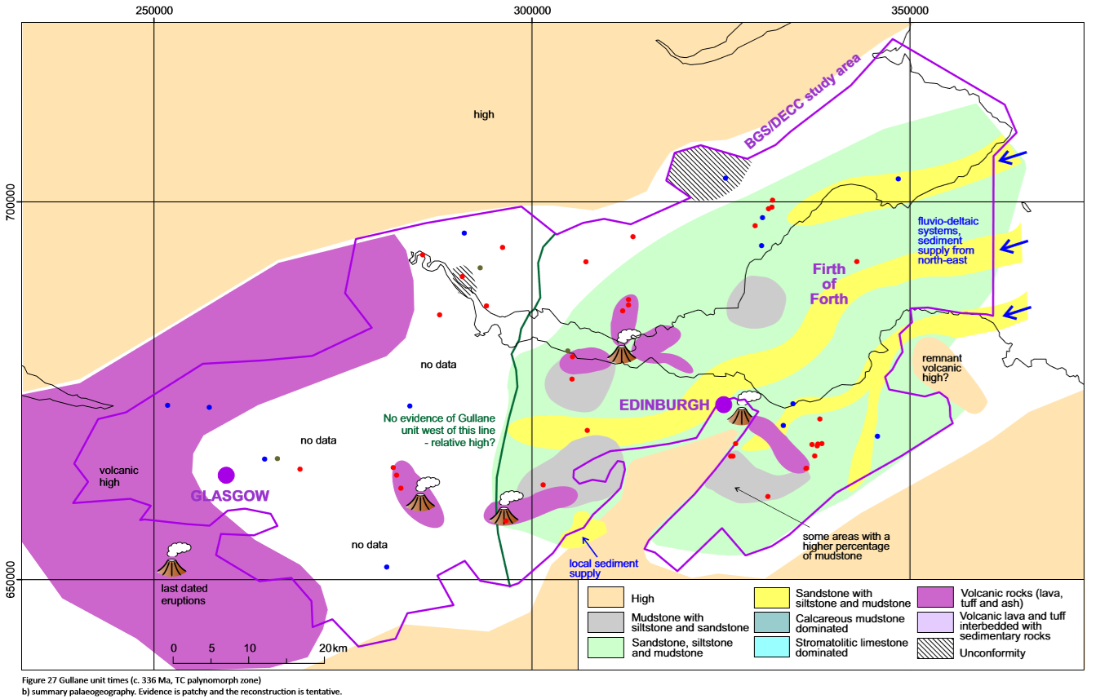

The West Lothian Oil-Shale Formation (Asbian to Brigantian age) is up to 1,120 m thick and is characterised by thin seams of oil-shale in a cyclical sequence dominated by sandstones interbedded with grey siltstones and mudstones. This formation, that crops out over a large area of West Lothian and on the western side of the Midlothian Syncline, displays important changes in thickness and sub-regional correlation of a number of oil-shale beds. Thick argillaceous beds containing volcanic detrital components are also present (Jones 2007), together with beds of tuff and ash. It also comprises layers of coal, ostracod-rich limestone/dolostone, sideritic ironstone and marine beds, including bioclastic limestones with relatively diverse marine faunas (Browne et al. 1999). The oil-shales are interpreted as algal oozes formed in anerobic bottom conditions in shallow stratified lakes (Parnell 1988), though marine ostracods in some oil-shales imply marginal marine conditions existed (Wilkinson 2005, Jones 2007). Laterally, the formation passes into the Lawmuir, Pittenweem, Sandy Craig, Pathhead and Aberlady sedimentary formations, and the Kinghorn and Bathgate Hills volcanic formations. Percentage shale maps highlight the predominance of shale units greater than 15 m thick in the western Central Coalfield and in West Lothian. Eastern areas of Fife and Lothian contain a relatively high percentage of shale, but with far less in units greater than 15 m thick.

Palaeogeography maps (Loftus & Greensmith, 1988) proposed high ground to the north, south and west of Lake Cadell (Greensmith 1962, 1965), deltaic sandstones sourced in the NE and marine influence from the SE. Near the top of the West Lothian Oil-Shale Fm, volcanic rocks of the Bathgate Hills and Kinghorn volcanic Fm dominate the succession in the West Lothian-Falkirk and Central Fife-Firth of Forth areas. The Central Coalfield and parts of west Fife display successions rich in thick lacustrine mudstones with marine incursions. The thick shales of the upper part of the West Lothian Oil-Shale Formation indicates that this lacustrine depositional basin extended farther west than Loftus & Greensmith (1988) had evidenced for.

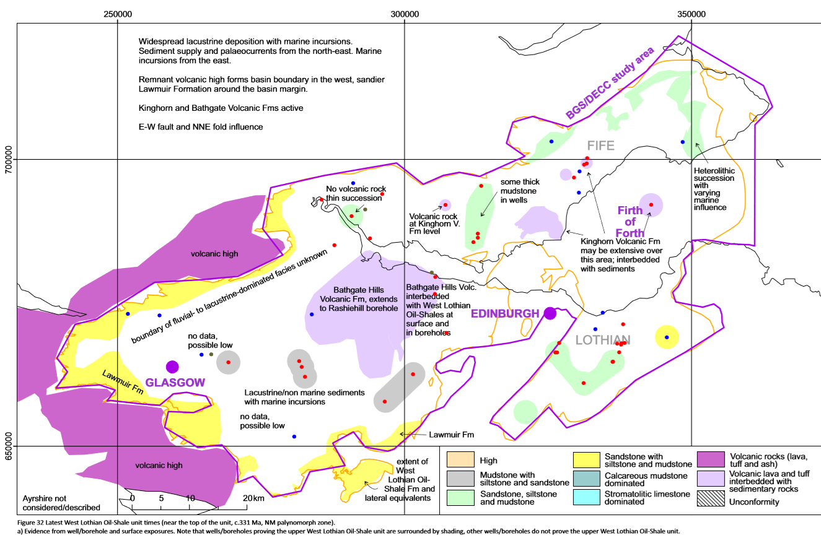

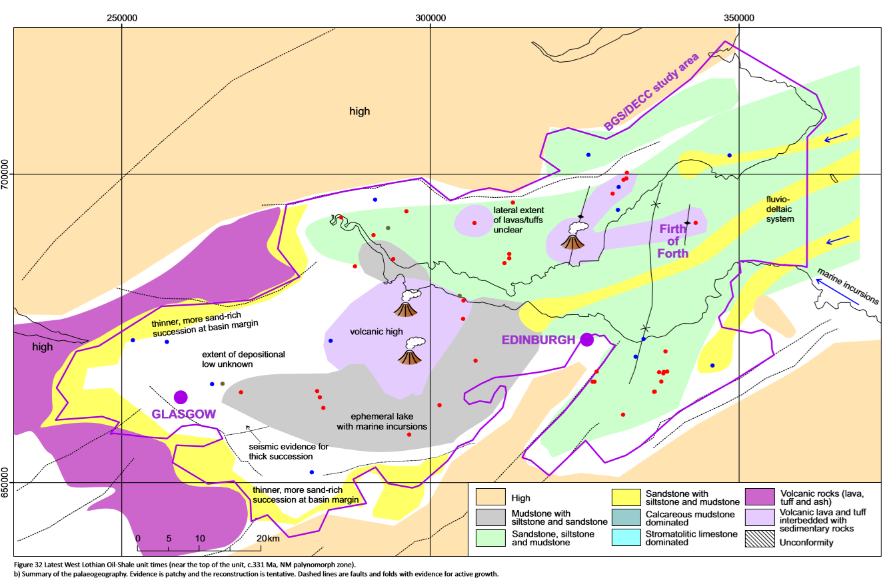

Palaeogeography for the lower West Lothian Oil-Shale unit (Burdiehouse Limestone level) highlights a time period of relative volcanic quiescence. This period is characterized by the lack of the Bathgate Hills and Kinghorn volcanic formation highs, no ‘Old Red Sandstone’ high in Fife and potentially fluvio-deltaic succession with narrower, mobile sand bodies and lagoonal/lacustrine environments in east Fife. The Burdiehouse Limestone divides the lower Pittenweem Fm (dominated by lacustrine mudstone, siltstone and marine mudstone/limestones >260 m thick) from the overlying Sandy Craig and Pathhead formations. The Sandy Craig Fm (<670 m thick) is mainly constituted by non-marine mudstone and siltstone, with thick sandstone layers locally developed. The Pathhead Formation (~220 m thick) mainly consists of mudstone and siltstone, with marine strata more common than in the Sandy Craig and Pittenweem formations (Browne et al. 1999). Overall, those units were deposited in deltaic to marine environments, closer to the siliciclastic sediment source and marine influence than the laterally equivalent, lacustrine-dominated West Lothian Oil-Shale Formation.

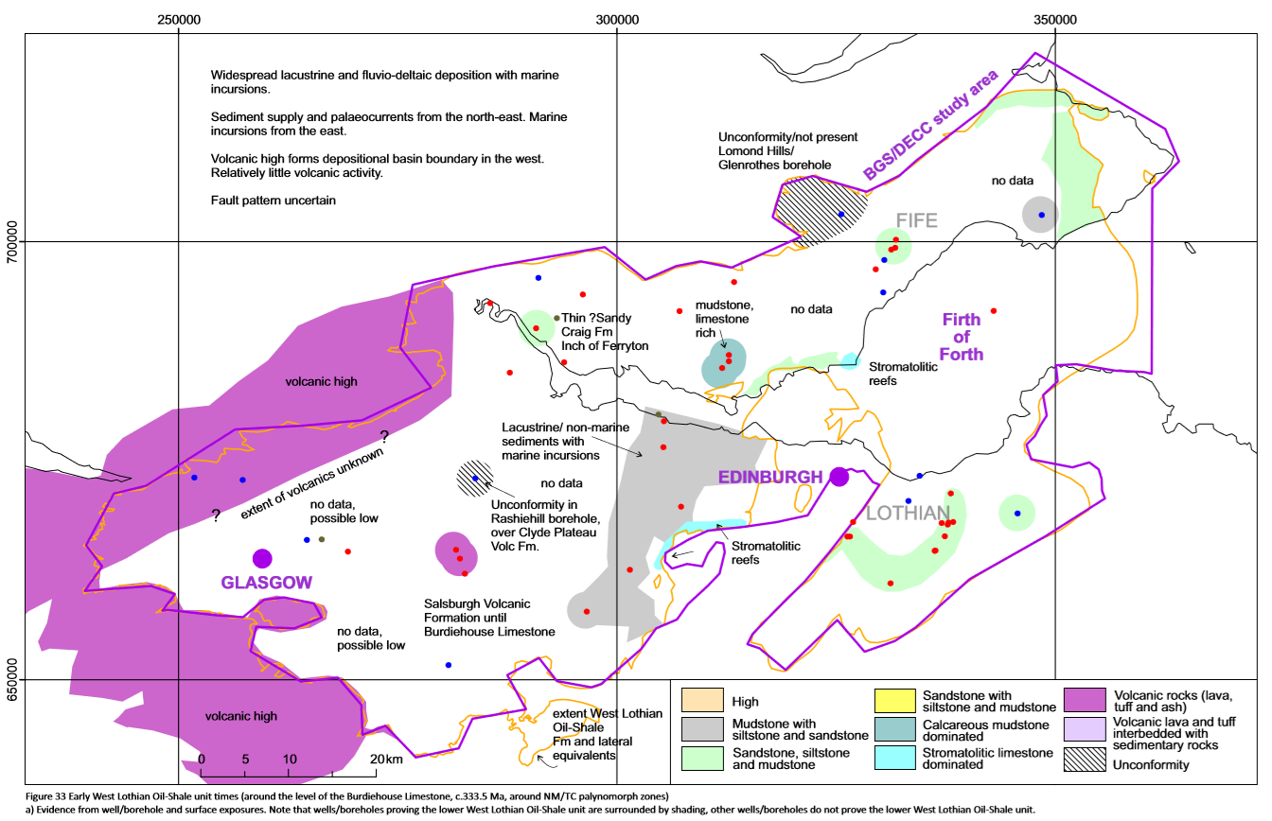

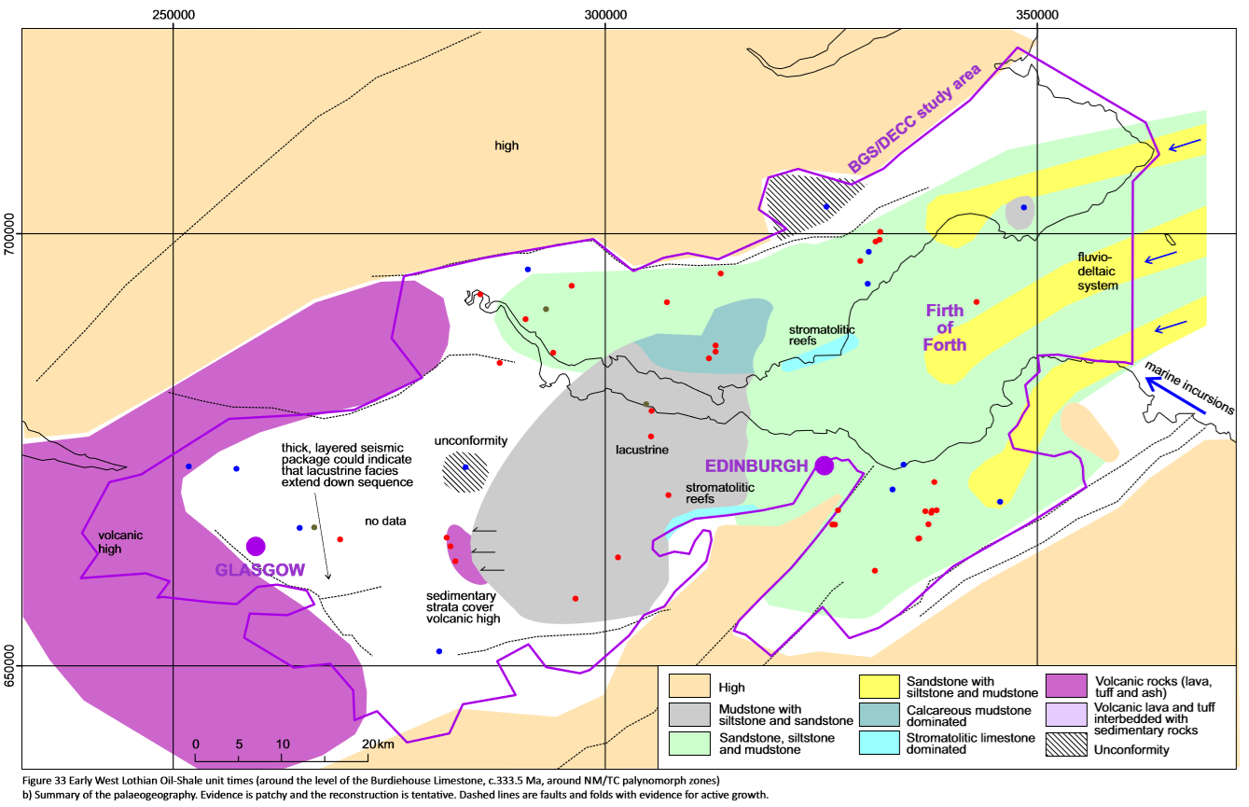

The Lower Limestone Formation (Brigantian age) is up to 240 m thick and consists of repeated upward-coarsening cycles of limestone, mudstone, siltstone and sandstone, with thin beds of seatearth and coal (Browne et al. 1999). The depositional environment is interpreted as the repeated advance and retreat of fluvio-deltaic systems into a marine embayment of varying salinity. Rocks of the Lower Limestone Formation are the most marine of the units. Limestone have been interpreted to be more dominant in the east (Lothian) and muddier, clastic-dominated in the west (Lanarkshire) (Goodlet, 1957; Wilson, 1989). Borehole data indicates a dominance of sandstone and limestone at the basin margins, and thinner limestones and thicker mudstones towards basin centres (Hall et al. 1998). Percentage shale maps for the Lower Limestone Formation reflect the high mudstone content of this formation, particularly in the west. The area of the active Bathgate Hills volcanism on the eastern side of the Central Coalfield has a negligible percentage of shale.

The Limestone Coal Formation (Namurian age) is > 550 m thick in places and comprises sandstone, siltstone, mudstone, seatrock and coal or blackband ironstones in repeated cycles. Numerous coals within this formation have been extensively extracted by deep mining and opencast methods in all of the Midland Valley coalfields. The palaeogeography for the Limestone Coal Formation highlights growth on syn-sedimentary folds and faults, and the palaeocurrent directions of fluvial systems taken from Read (1988) and Hooper (2004). Up to 30% of the lower part of the formation may be marine influenced. Stronger fluvial influences in the cyclical Limestone Coal Formation strata are noted in channel belts in the Clackmannan area and to the east of the Midland Valley (Read et al. 2002). Eruption of lavas and tuffs occurred in the Bathgate and Saline hills. The percentage shale maps have high values in the north, north-west and western Central Coalfield. Relatively high percentages of shale are also shown in the Midlothian-Leven Syncline, though the number of shale units thicker than 15 m is relatively low due to the small scale of fluvio-deltaic cycles here.

